Annual report
September 2020
The moment partners found out their project was granted they started preparing activities and setting up management roles as specified in the project proposal. However, we experienced a bump in the road. Our partner from Ireland decided to pull out so we spent some time negotiating and persuading them to stay partners. In the end, the project ended up with 2 partners from Serbia and Slovakia. We were also dealing with eTwinning platform, since one project coordinator was not added as an administrator which automatically meant she could not add teachers and students to the project. It was solved at the beginning of October so eTwinning was up and running full steam. Steps were taken to start a project site – IT teacher and a Serbian teacher were assigned to create and maintain the site. This was the responsibility of our Irish partner so coordinator school, after discussing it with its partner school from Slovakia, took it upon themselves to start the site.
Students and teachers from both schools started filming materials for creating the introductory video. Tasks were divided to all planned participants – both teachers and students. Since we wanted to present more of desired school premises, we included the larger number of participants than planned. There were 50-60 students from Serbia and 40-50 students from Slovakia. There were 30-35 teachers included in the activity from both schools.
The second activity was Pen Pal letters planned for the end of September. Due to the late beginning of the project and all uncertainty of the project approval (it was not clear from the beginning what will happen to the project after the partner from Dublin decided to pull out) we decided to push this activity to October.
RELEVANT LINKS:

https://thisishowweshare.com/ project site
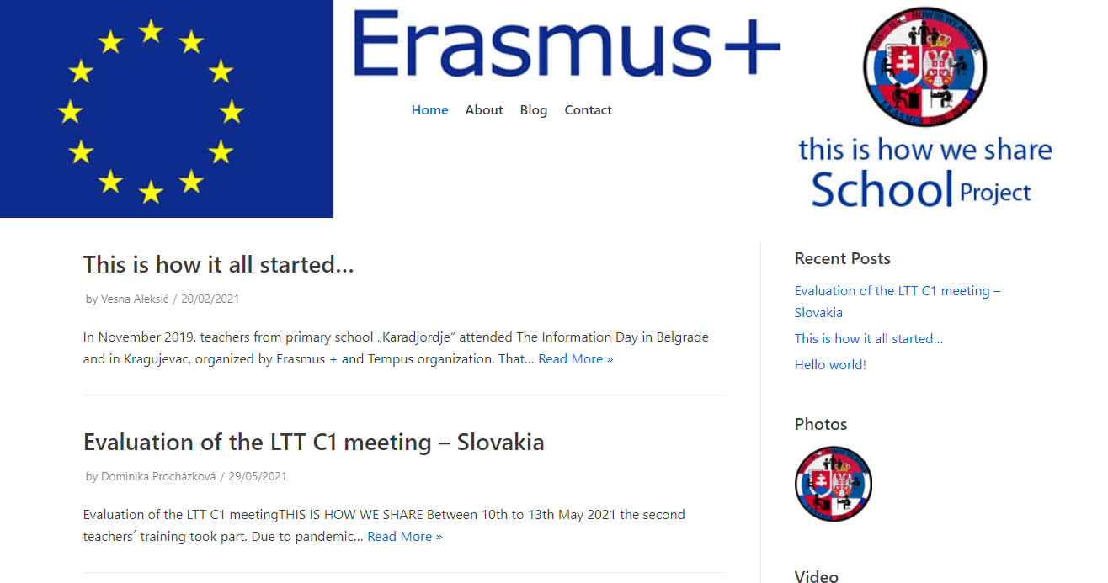

https://youtu.be/IwW8S3BB9FI introductory video 1 Serbia
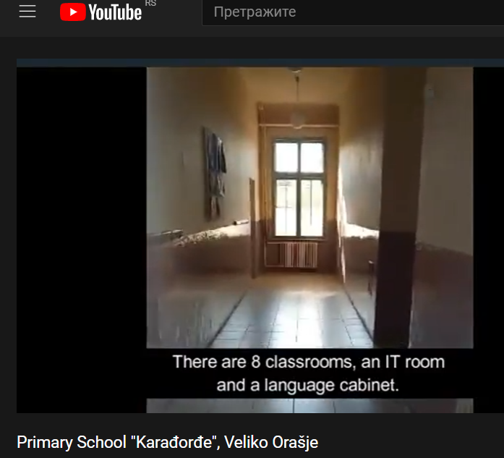

https://youtu.be/65N8ZqJFxsw introductory video 2 Serbia
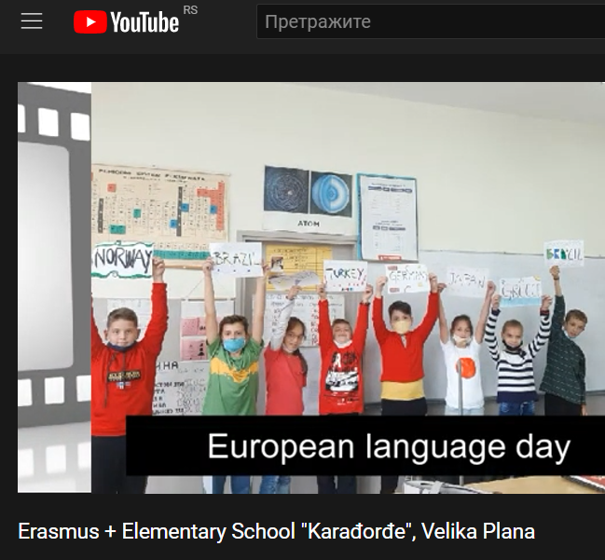

https://www.youtube.com/watch?v=ENl97D7er8g introductory video 3 Serbia
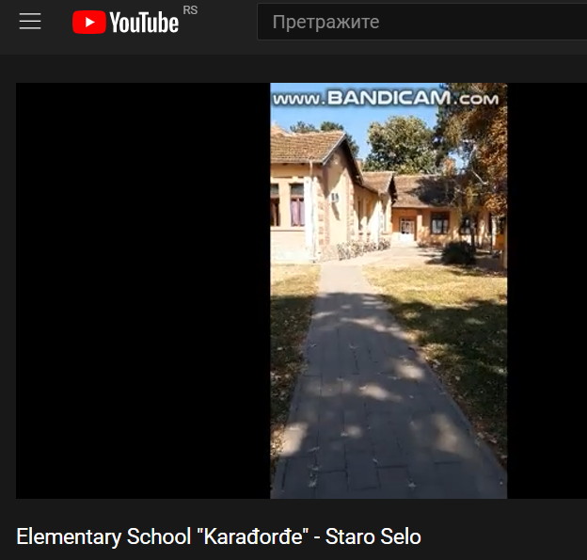

https://www.youtube.com/watch?v=fsOh6VSyu6M introductory video Slovakia
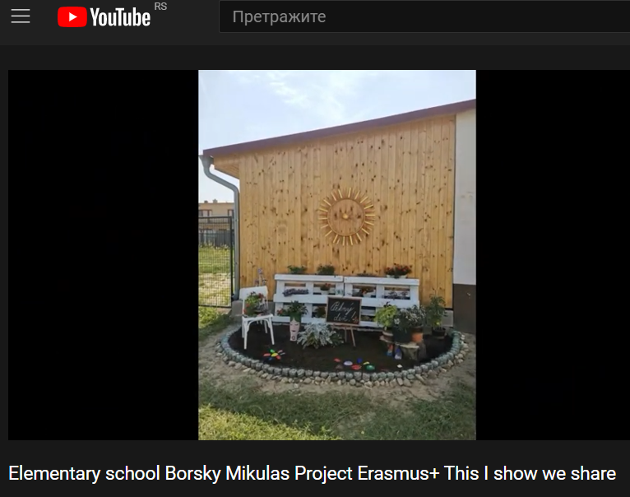

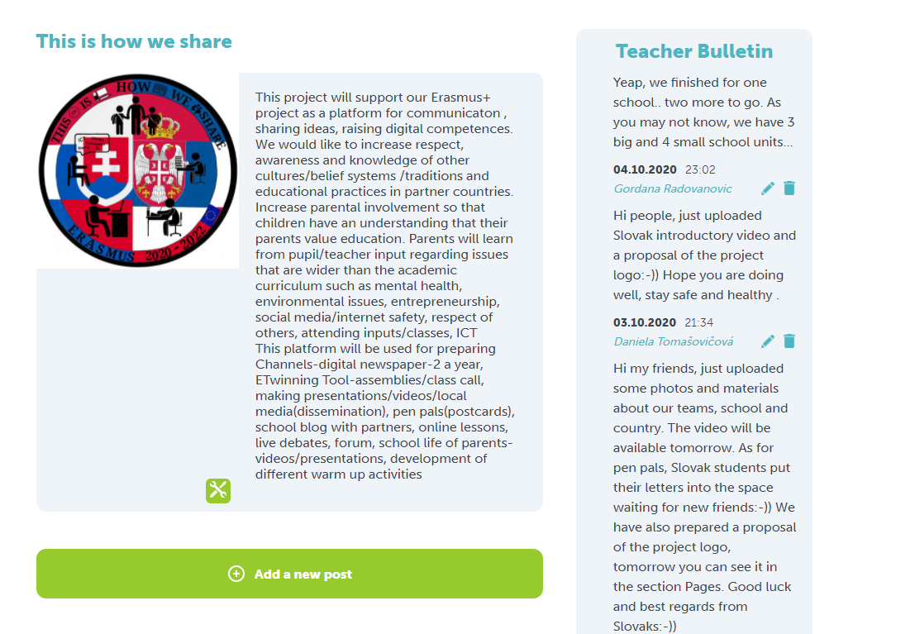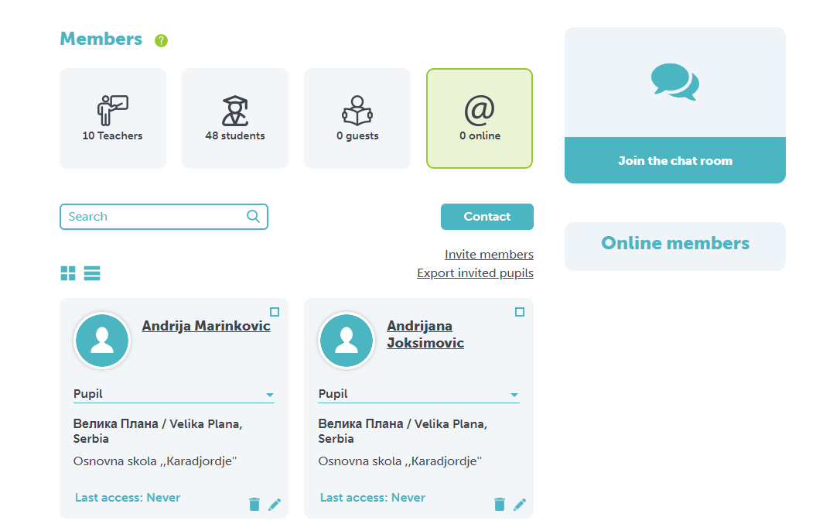

October 2020
In October after the coordinators’ meeting, we waited for the approval of the new eTwinning ‘This is how we share’ project because we needed to start without our partners from Ireland. Daniela, a coordinator from Slovakia, had it approved and she added Gordana, a coordinator from Serbia, to the project. We then each added our teachers and students to the project.
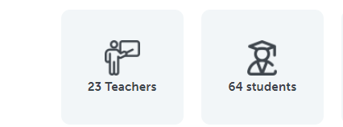
Students had a task to write something about themselves and read profiles of students from a partnering school. Then, they were supposed to send some messages to their friends and start correspondence in English. Students wrote about their interests, families, schools and countries. This was a novelty for some students so they were really interested in doing it. Here are just some of the letters.
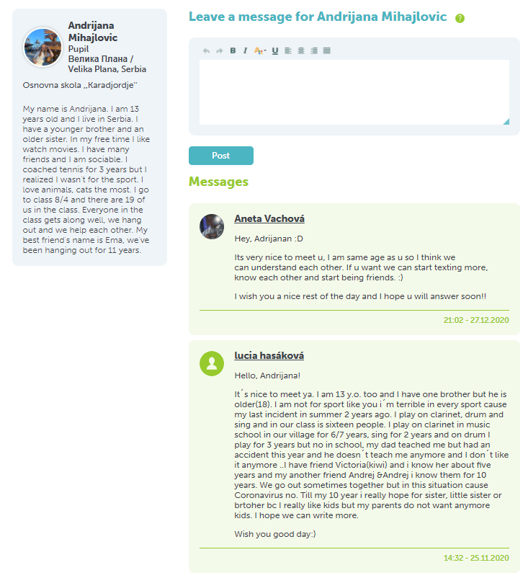
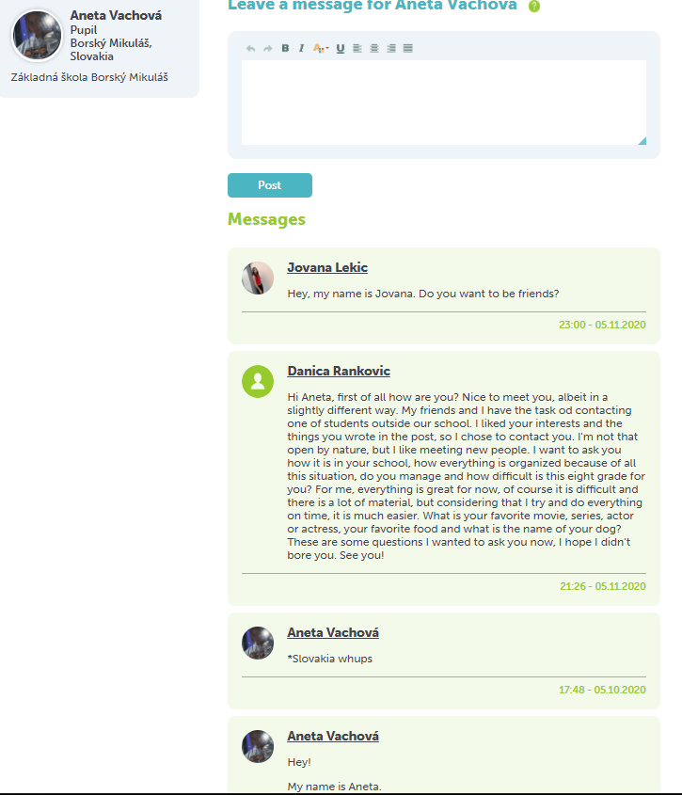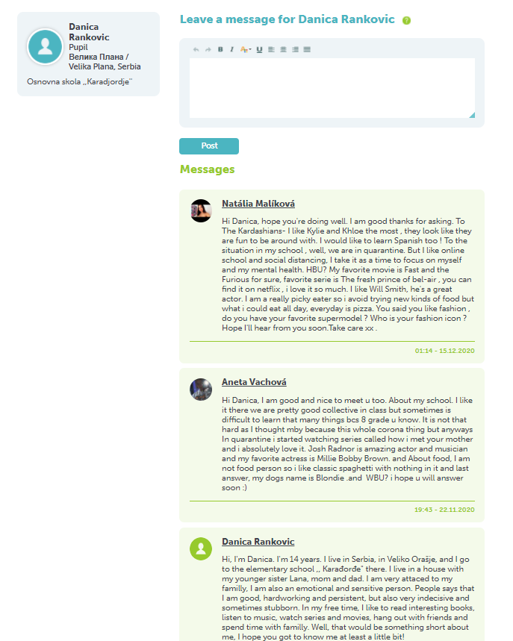
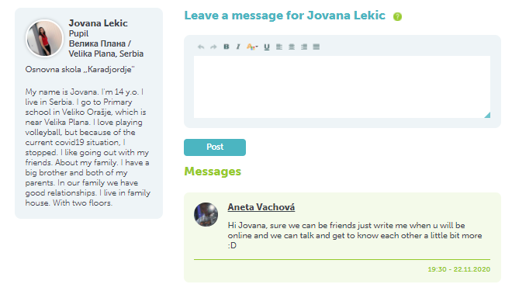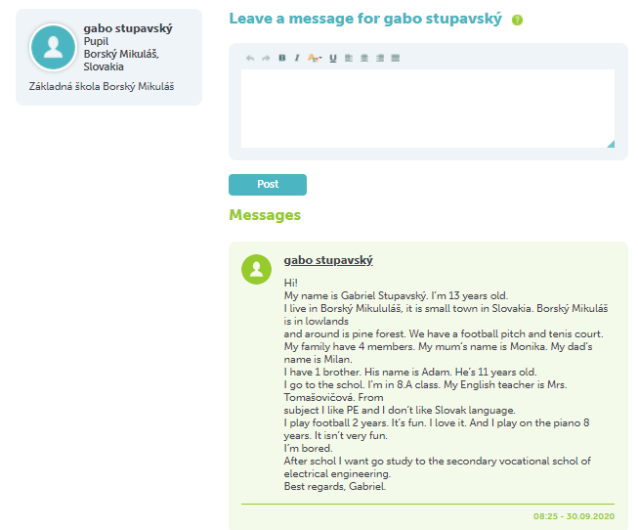

At the beginning of the month, we had a meeting which was to discuss the preparation and finalizing of our C1 LTT activities which were supposed to be held in Slovakia.
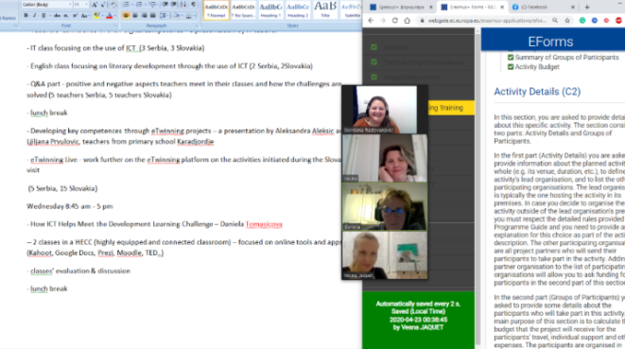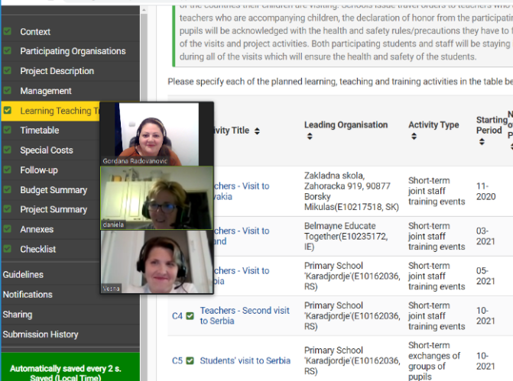
Due to COVID travelling restrictions this activity was postponed until further notice. Instead, partners discussed and agreed upon the smaller changes’ application. Since our partner from Ireland dropped out and it was approved to have only 2 partnering schools on the project, we contacted Serbian National agency Tempus to advise us on further steps.

This is what we have submitted
1. Instead of C2 planned LTT for teachers in Dublin, we planned 2 LTT activities in Slovakia
- LTT for students: 5 students and 1 teacher
- LTT for teachers: 4 teachers
2. Instead of C8 and C9 LTTs to Dublin, we planned 2 LTTs in Serbia
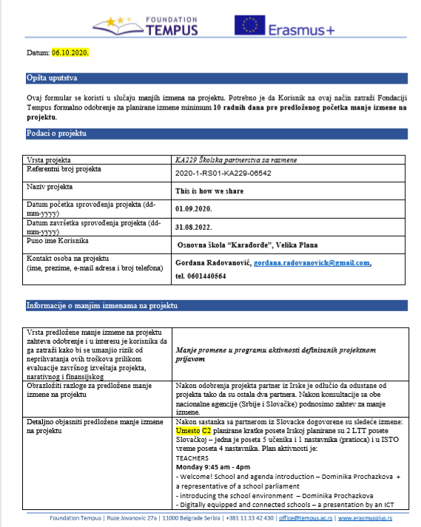
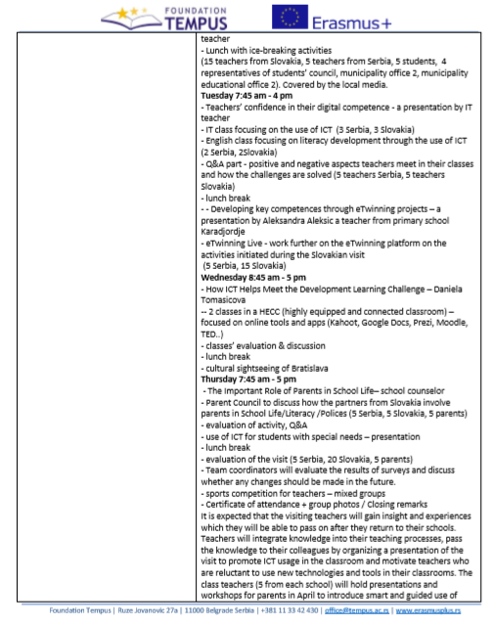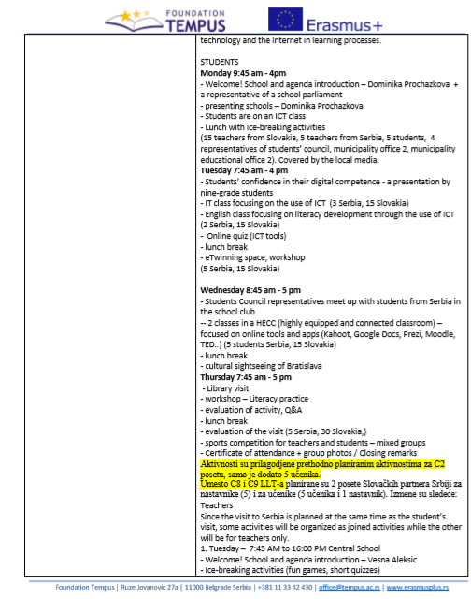
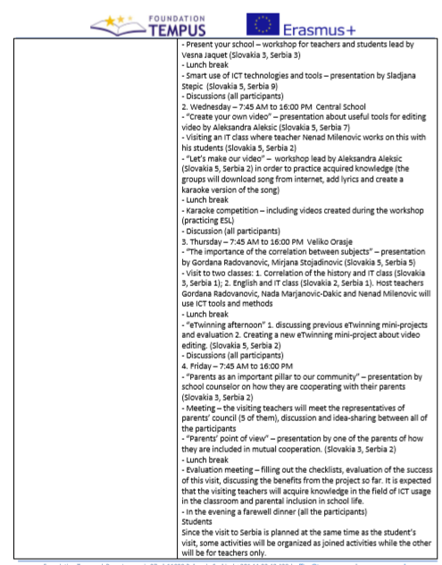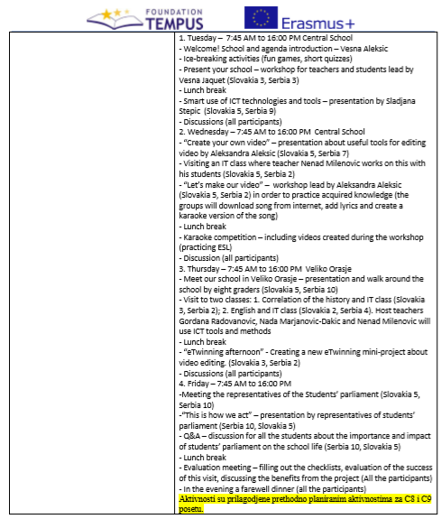
This application was approved.
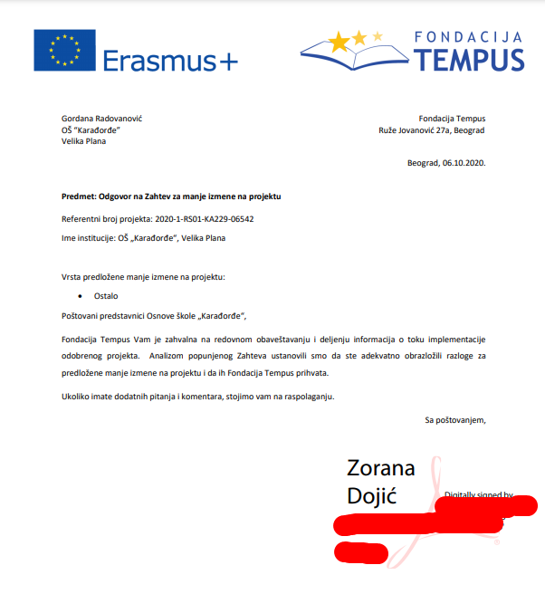

November and December 2020
At the end of November, we met up on Zoom to discuss December activities. We planned to start working on a singing competition which would be held in December (this activity was originally planned for September 2021 – however, since we couldn’t travel, we decided to do this one instead). Students started writing song on the topic of friendship. Their English and music teachers were supposed to supervise the process. Students from Karadjordje school created the text, teacher Vesna Jacquet supervised the activity and teacher Jelena Miljevic, a music teacher, arranged the music for the song.
https://youtu.be/6ZV1g34EQRs
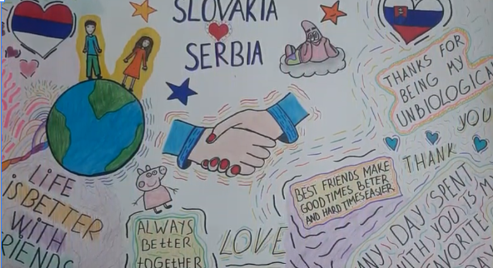
Unfortunately, students from Slovakia were having online lessons since the beginning of October so teachers couldn’t gather all of them to make a song. Instead, they made some Christmas cards for their student-friends from Serbia and they were posted to eTwinning. We will continue with this activity as soon as the students from Slovakia return to their schools.
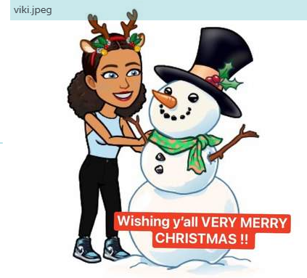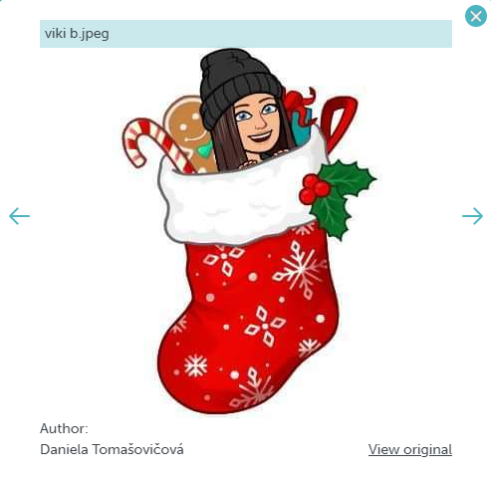

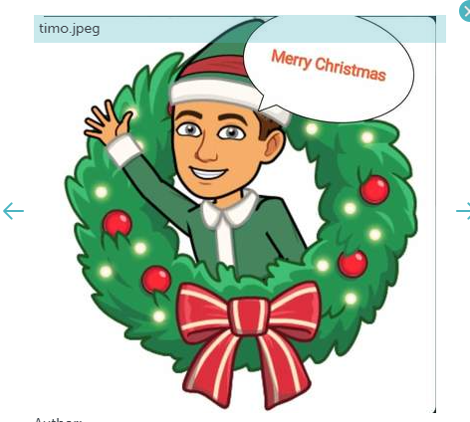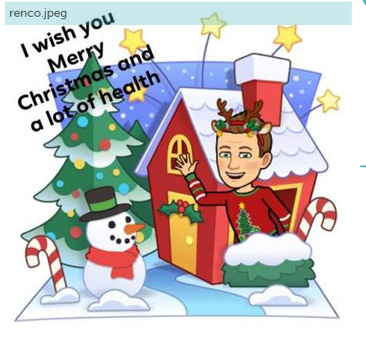
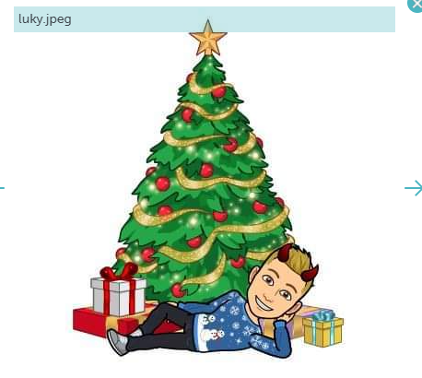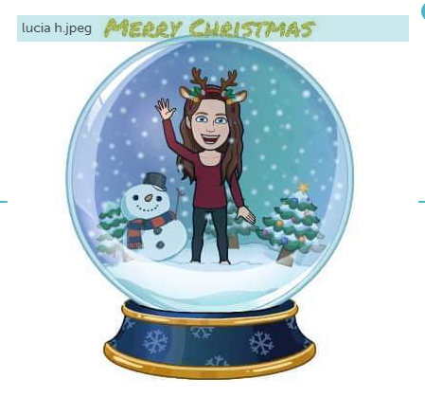

January 2021
Planned activities for January were:
Celebrate the International Day of Education
1. a Prezi presentation “The role of information and communication technologies in improving teaching and learning processes in primary schools” for students and their parents in the school assembly or gym to promote school activities – 3 teachers from each school host a presentation to a number of students and parents (Ireland 150 students, 150 parents, Slovakia 90 students, 90 parents, Serbia, 180 students, 180 parents).
2. Workshop - Pair work activities (general knowledge quiz) for students and parents, evaluation sheets - 5 other teachers from each school help the organization and delivery of the activity - 1 teacher from each school uploads the activity report and photos/video on project website to disseminate the activity results - Covered by local media if possible. Total number of participants: 27 teachers, 420 parents, 420 students
Due to COVID restrictions, we had to rearrange this activity a bit. Instead of meeting up in the school assembly our teachers, Aleksandra Aleksić (Serbia) & Rudolf Hrebačka (Slovakia) made videos for parents and students in their mother tongue. u can check the following links:
Serbia - https://youtu.be/959axSk4ml0 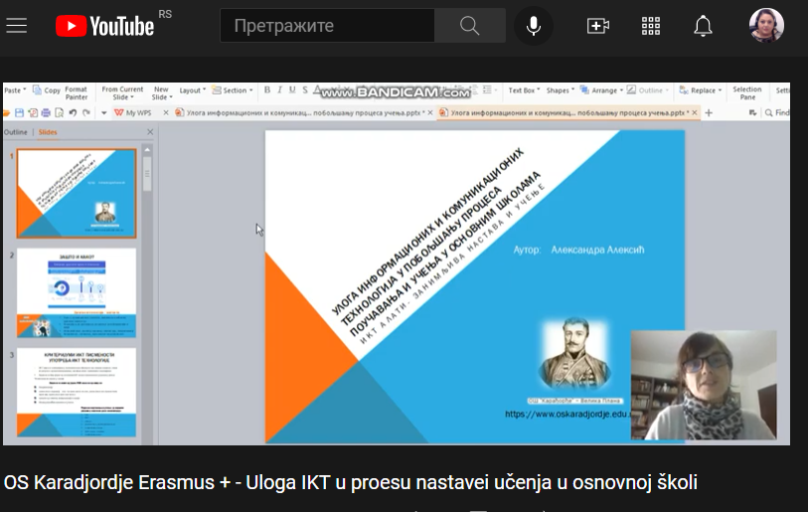
Slovakia - https://youtu.be/w7URFkd1Uow
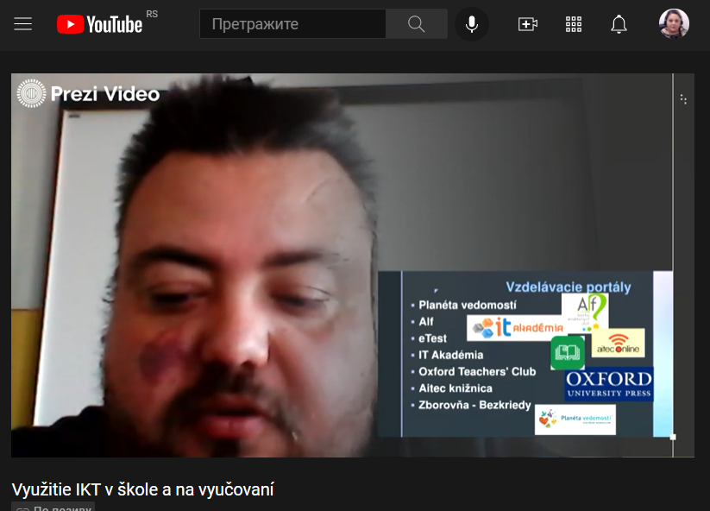
These videos were sent to parents and students to watch after which they had to create a questionnaire to check their knowledge. The planned number or participants was Slovakia 90 students, 90 parents, Serbia, 180 students, 180 parents.
We included Serbia – 179 parents and the same number of students.

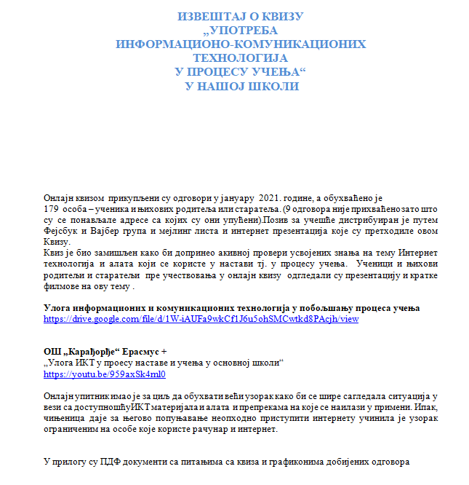

https://drive.google.com/file/d/1W-iAUFa9wkCf1J6u5ohSMCwtkd8PAcjh/view

https://mail.google.com/mail/u/0/?tab=rm&ogbl#search/aleksic026%40gmail.com/FMfcgxwLsShbhHBxSFphRkzNPVlsBFDz?projector=1&messagePartId=0.3

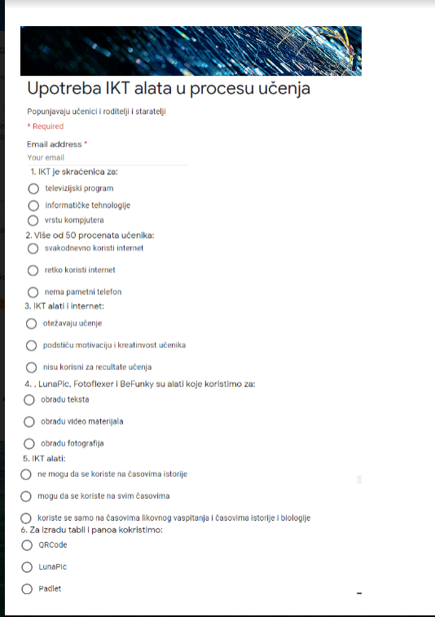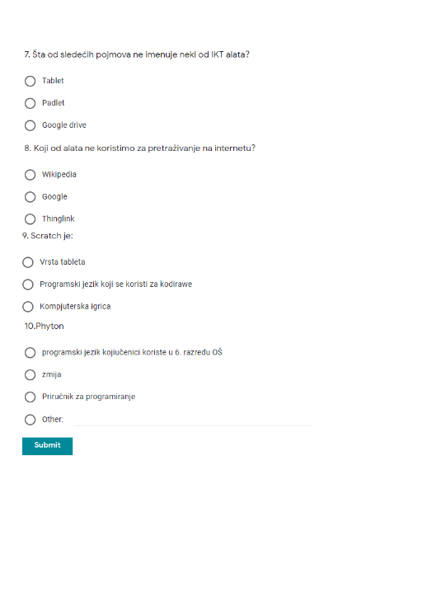
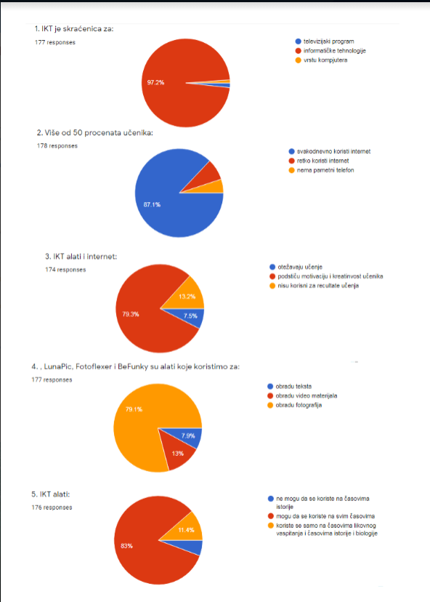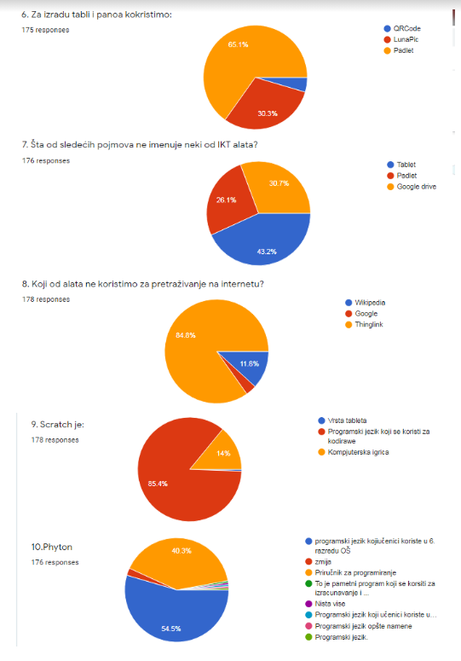
In Slovakia we included 55 parents and that many students.
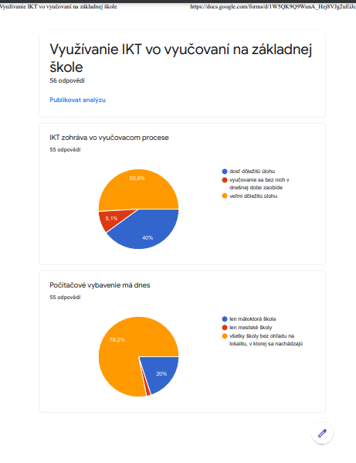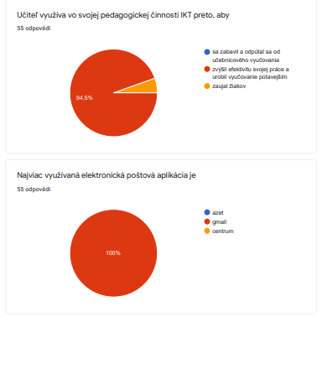
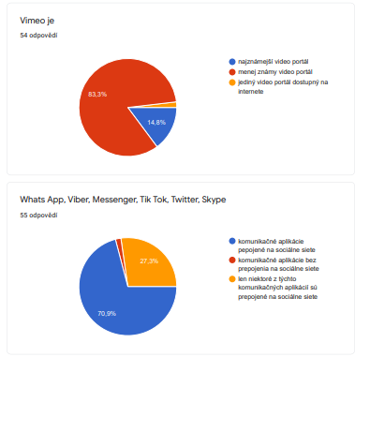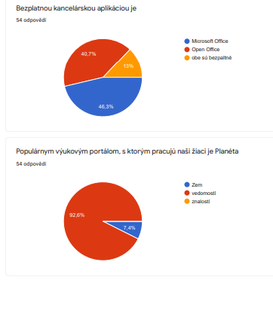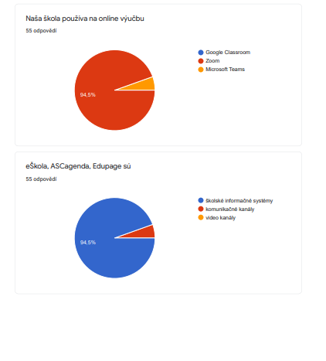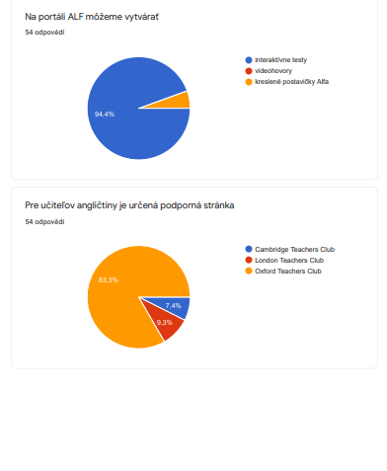
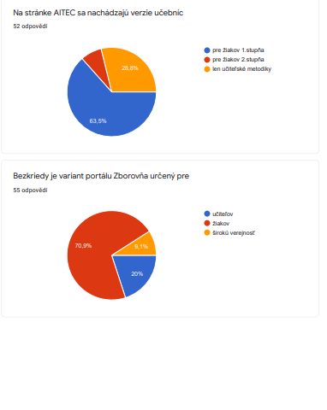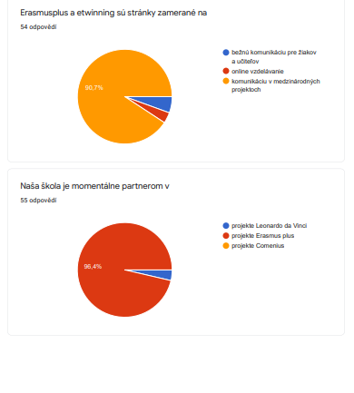
Activities are on eTwinning as well
Activities are on eTwinning as well
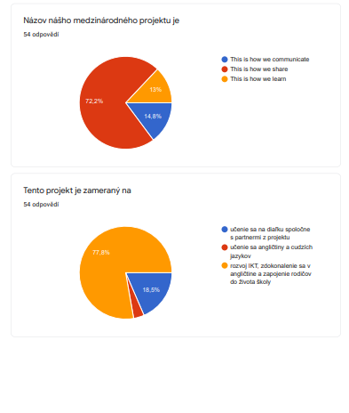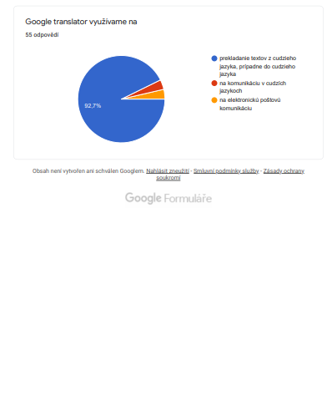
Activities are on eTwinning as well
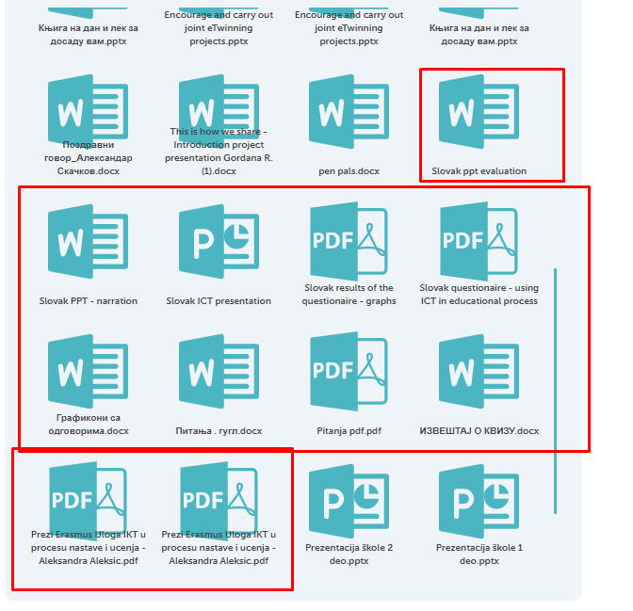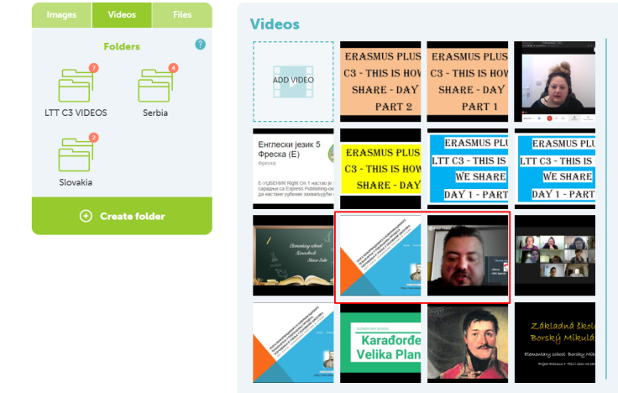

February and March 2021
Planned:
In February, all partner schools will meet up on Twinspace to discuss and organize activities related to the visit to primary school, Belmayne ETNS in Ireland- (coordinators and 2 other teachers from each school in charge of the trip preparation). The purpose of the meeting is to finalize the details of the visit. The minutes of the meeting will be uploaded and visible on eTwinning platform and on the project site. Total number of participants: 9 teachers
Since there are only 2 partner schools, Karadjordje and Borsky Mikulas, we met up to discuss and arrange online LTTs. The meeting was scheduled on eTwinning.
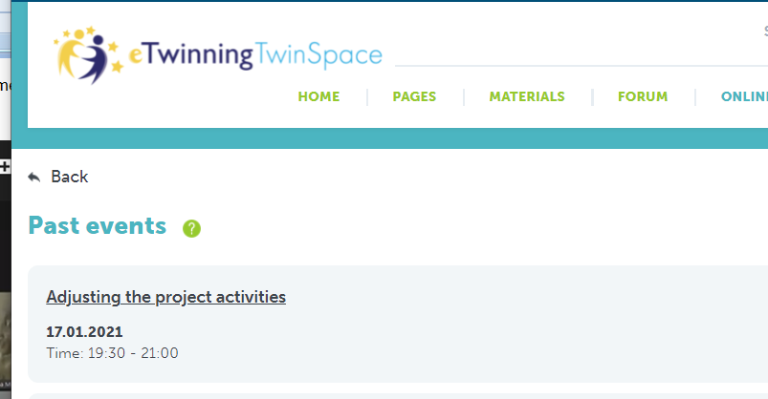

We had a lot of difficulties with connecting due to technical issues – bad internet, slow computer, lack of technical skills… so it took half an hour before we decided to meet up on Zoom. Links were sent and people joined. We introduced to each other, talked about the project activities we did and those we plan to do. Everyone was a bit shy at the beginning but as time passed, we felt more relaxed. We’ve decided to organize our LTTs online and we talked about the means and tools we are going to need to realize the activities.
https://youtu.be/SCdiEk31y0Y

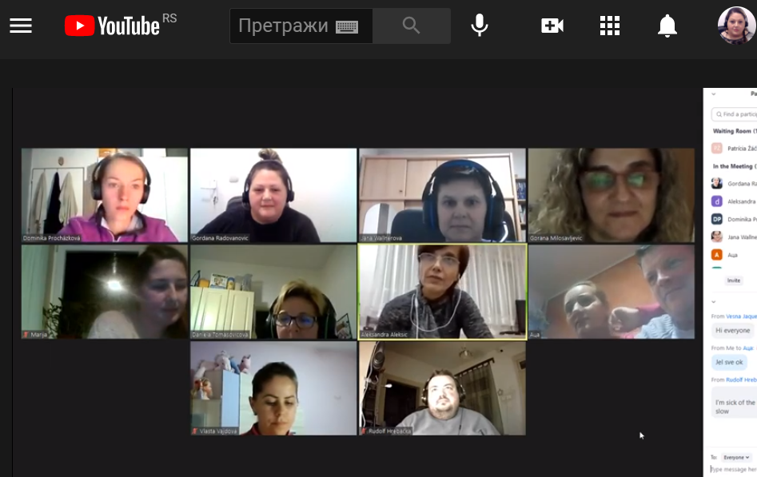
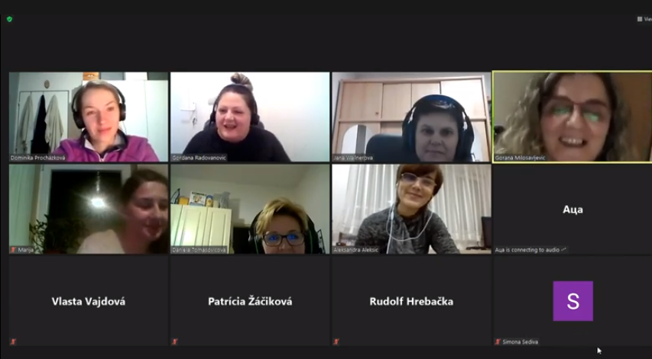
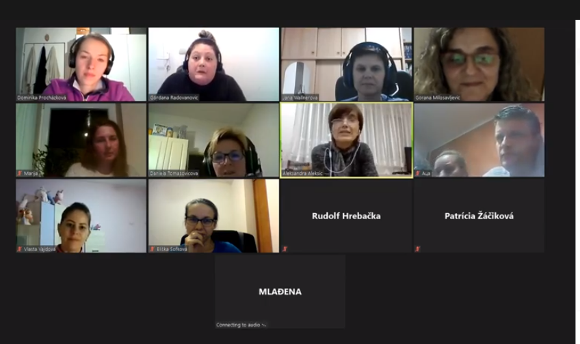
We did not have any activities in March concerning traveling for LTT because of the current COVID situation. However, Daniela, Dominika, Vesna A and Gordana met up on Zoom to finalize the details of the planned LTT C3 that Serbia will organize in April. We decided to do LTT C3 first because we had more manpower to help with the organization.

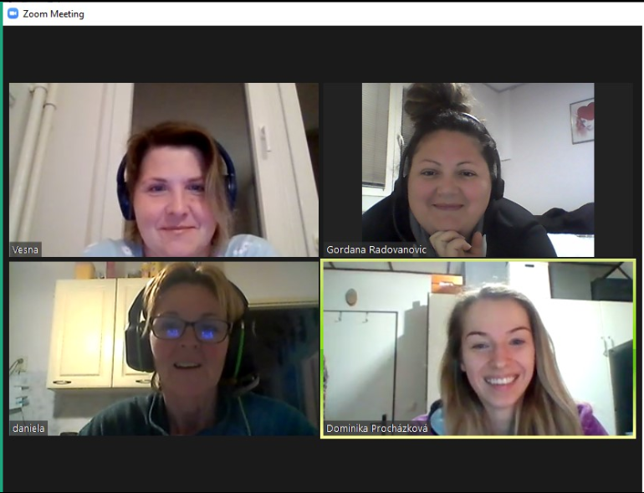

April 2021
As it was agreed upon during our last meeting that the first LTT activity was going to be C3. The LTT for teachers was planned for 5 days April 12-16. Every activity planned by the original project version was fulfilled except the activities which included sightseeing and cultural visits. Here is the agenda of the LTT.
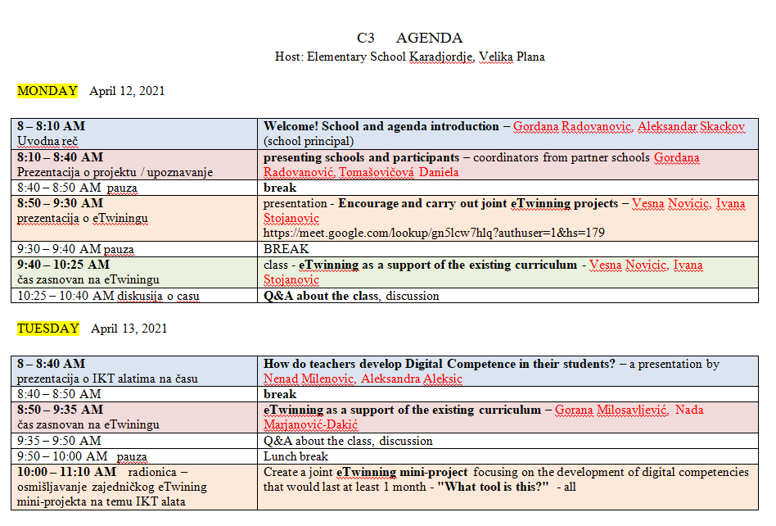
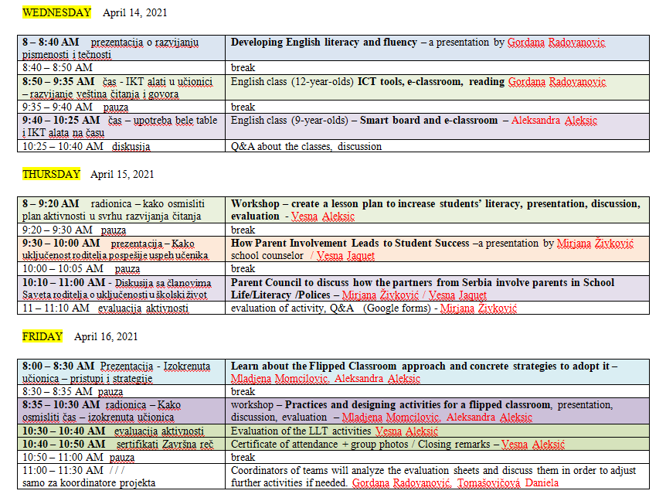
Before the beginning of the LTT coordinators carefully discussed details and sent all the necessary information via email and messenger. Zoom events were created and invitations were sent to all the participants.
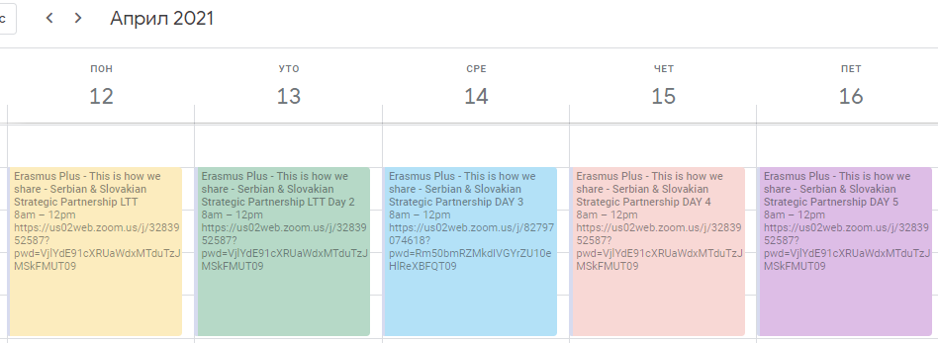
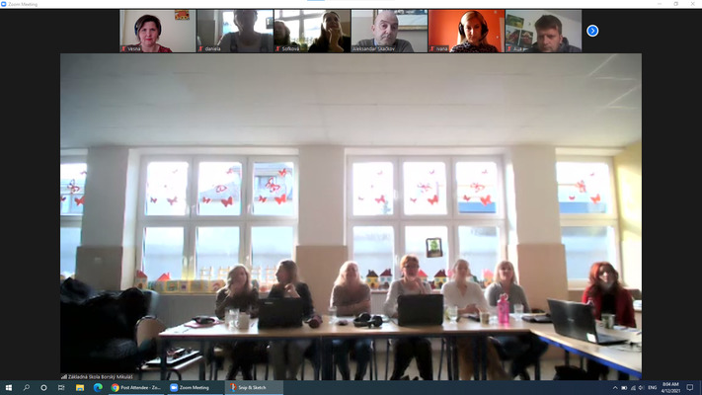
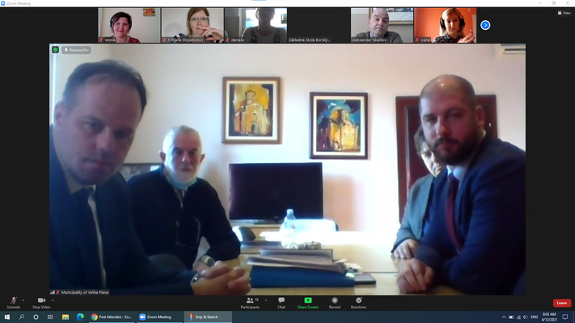
On the first day, school principal from Serbia Aleksandar Skackov welcomed the guests – teachers from Slovakia, teachers from Serbia and the representatives from the local government. There were 11 participants from Borsky Mikulas, 20 teachers from Karadjordje and 5 people from the local government (the mayor and his associates). After that, Gordana Radovanovic, the project coordinator, gave a Prezi presentation introducing the project, main goals and the activities done so far.
VIDEO LINKS> https://youtu.be/dW9n4bLt9pQ / https://youtu.be/09pnedFw1Q8
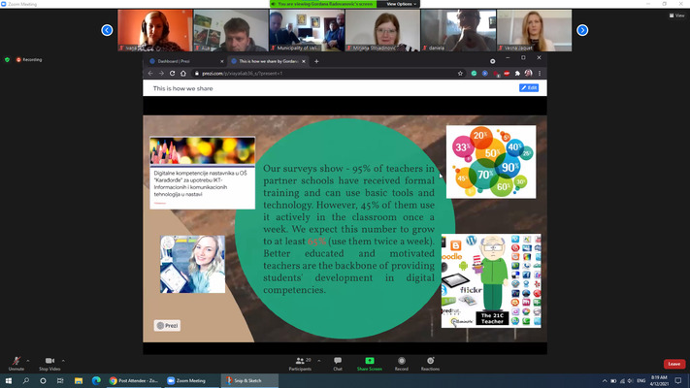
https://prezi.com/p/xiaya6ab36_s/?present=1
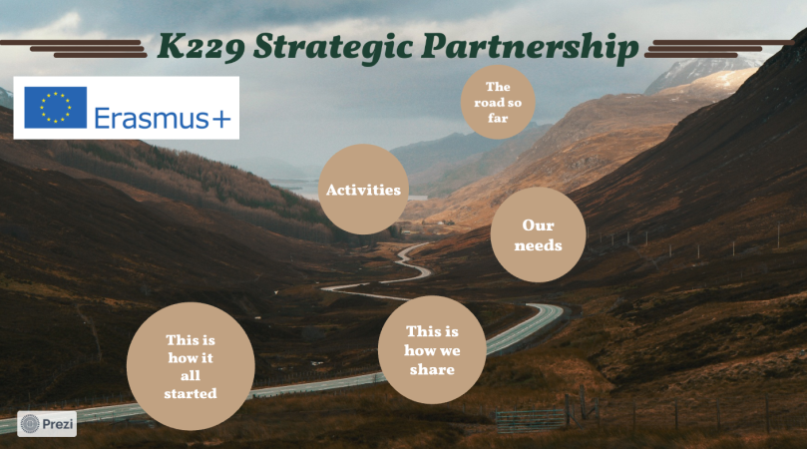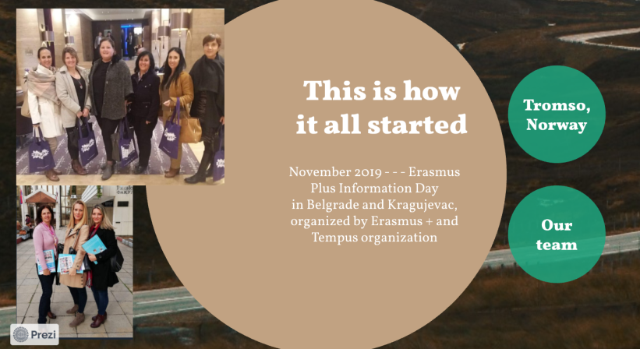
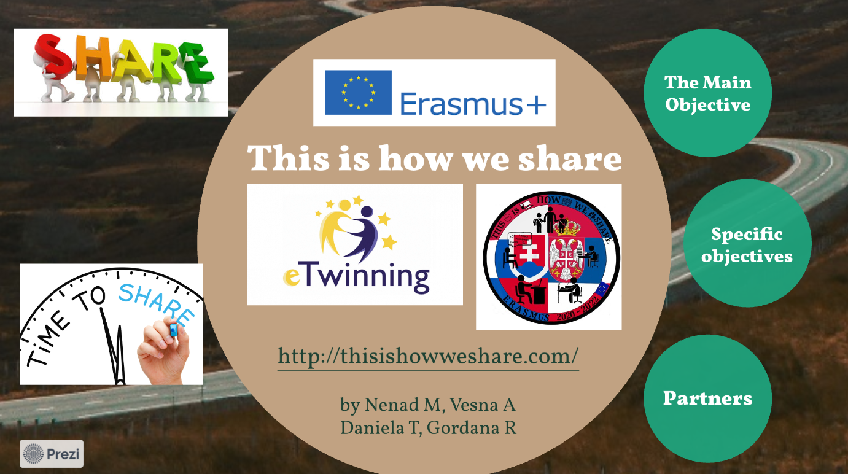
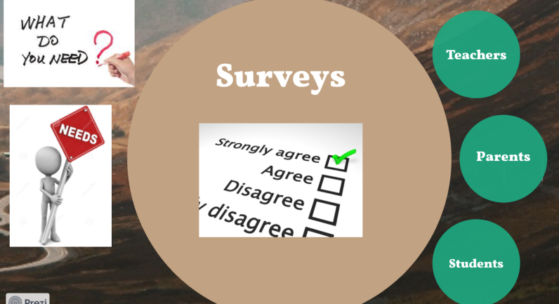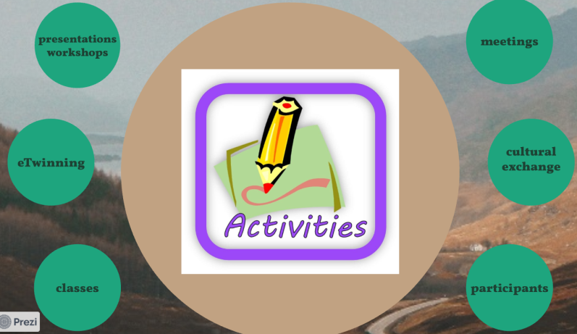
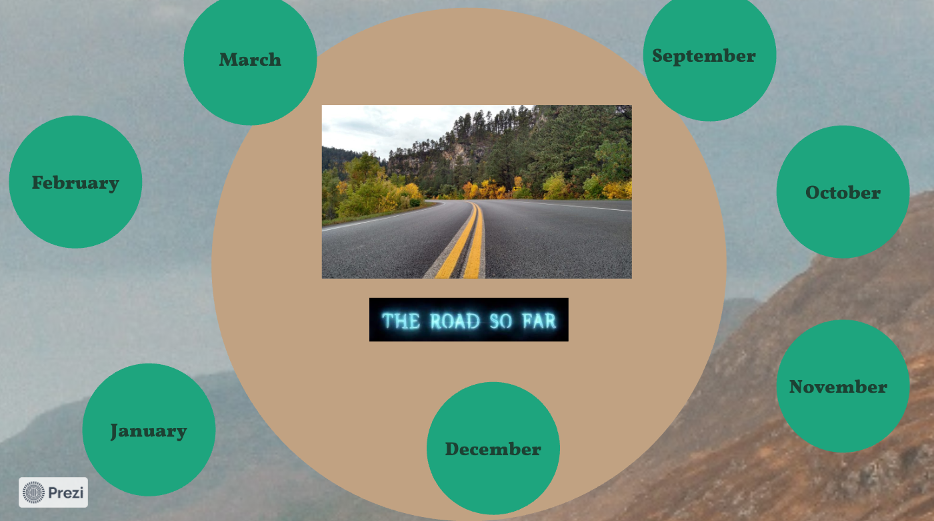

Colleagues Ivana Stojanović and Vesna Žake then talked about the importance of eTwinning and how to design and implement this type of project, after which they held an online eTwinning class on "My favorite character".
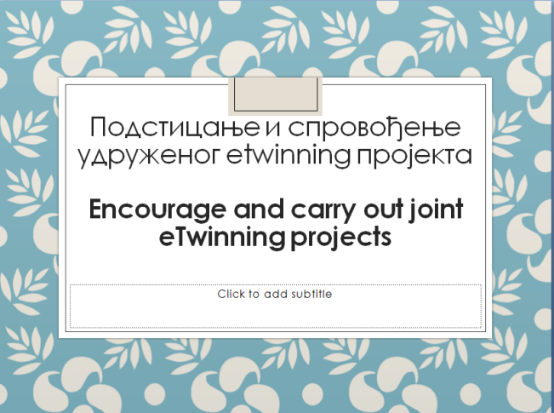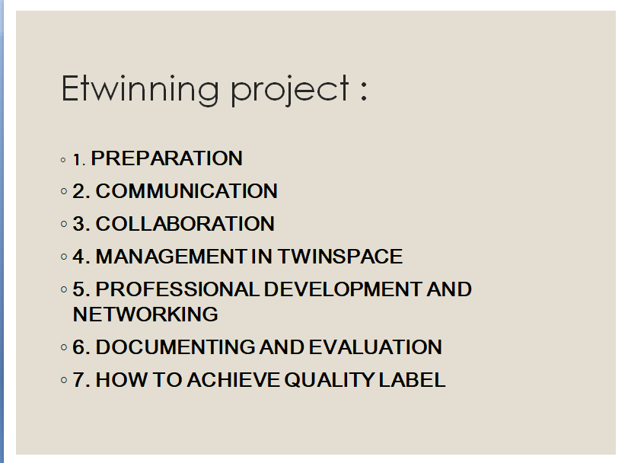
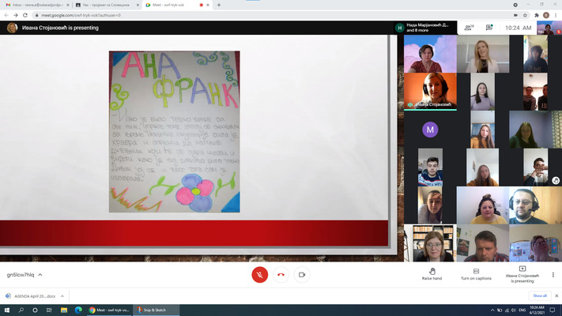
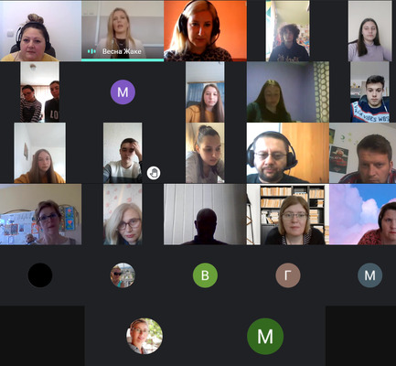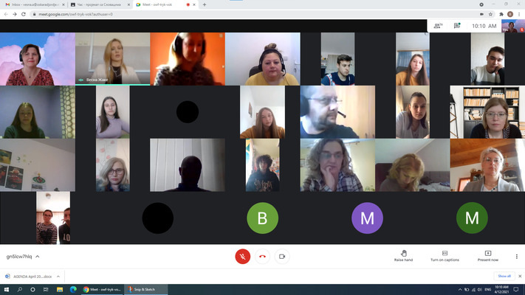
On the second day, colleagues Aleksandra Aleksić and Nenad Milenović held a presentation on "How teachers develop digital skills in their students". After discussion and analysis, colleagues Gorana Milosavljević and Nada Marjanović-Dakić held an eTwinning class on "Slovenian mythology". The last activity of the day was an agreement to create a mini-eTwinning project "What is this tool?" Which will last 6 months.
VIDEO LINK > https://youtu.be/0NYrya9XTB0
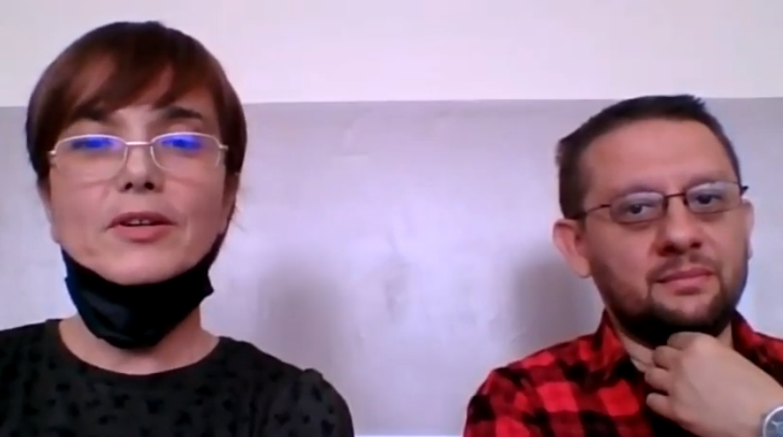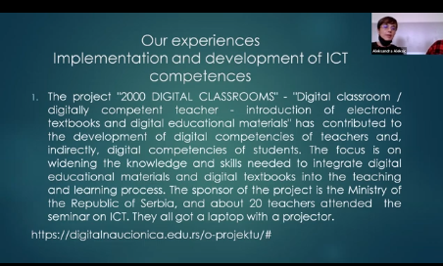
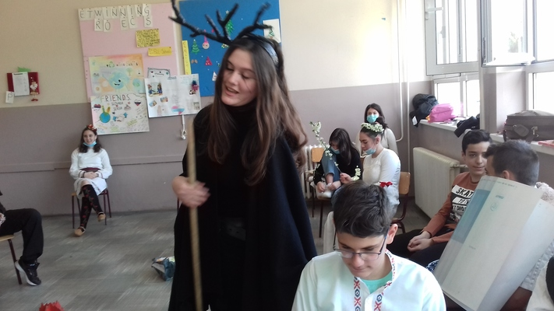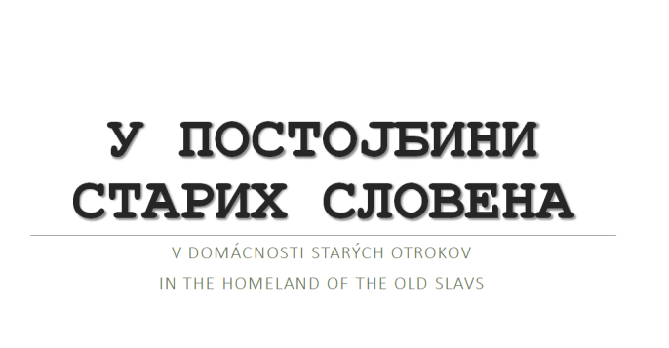
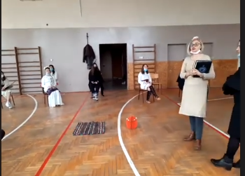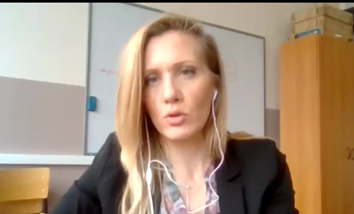
On the third day, colleague Gordana Radovanović held a presentation on "Developing fluency and literacy" followed by an online class with fifth graders from Orašje to present the use of modern tools in developing literacy and fluency, and colleague Aleksandra Aleksić held a class with third graders from Veliko Orasje to present work with an interactive whiteboard.
VIDEO LINKS > https://youtu.be/d7We8iKP3qE / https://youtu.be/UZaaHSlsBfw

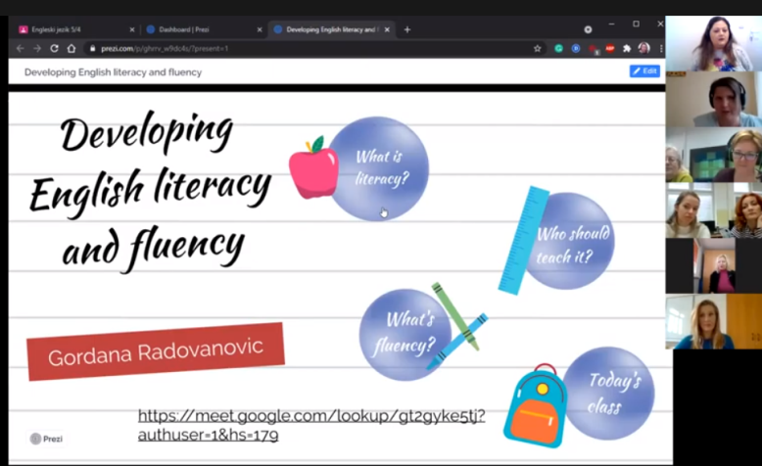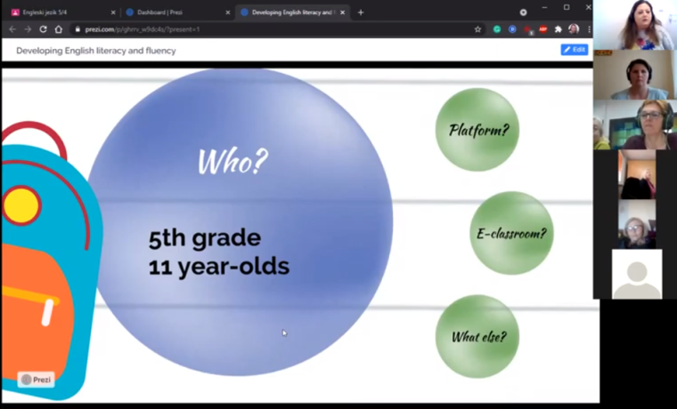
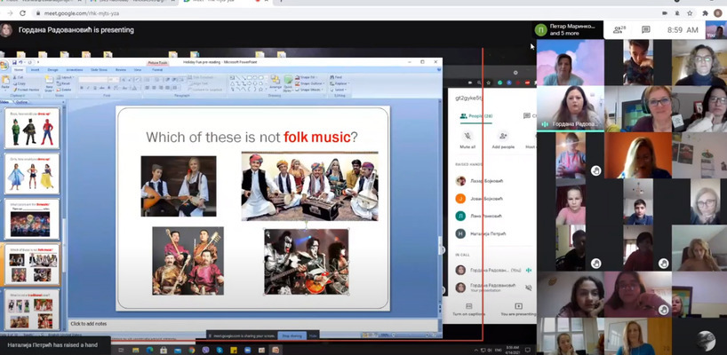
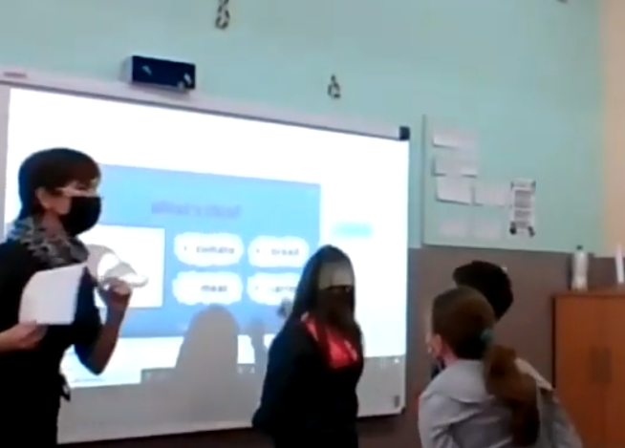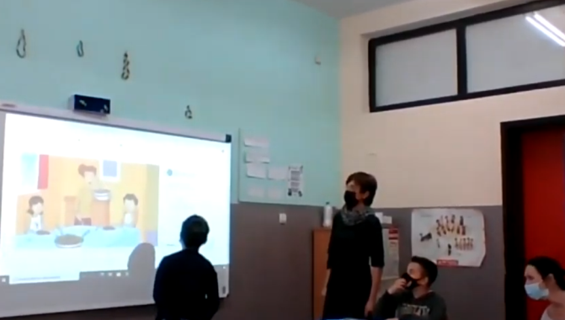

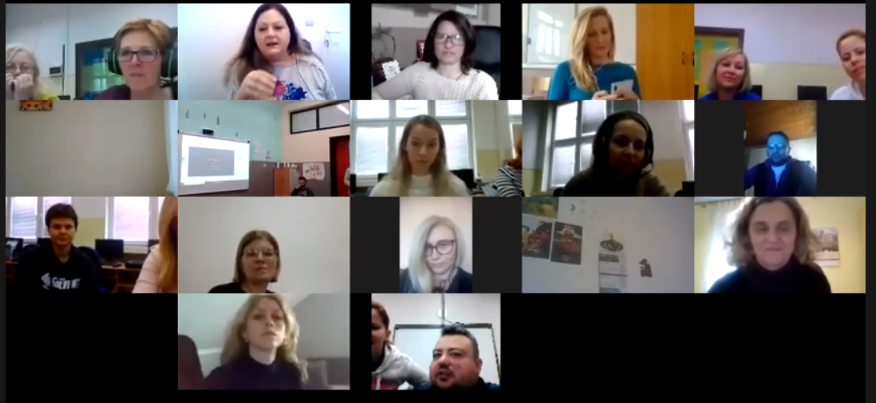
On the fourth day, colleague Vesna Aleksić held a presentation and workshop on "Developing Literacy", after which colleague Mirjana Živković held a presentation and workshop for parents who came to school on "How parental involvement leads to student success". Translation assistance was provided by my colleague Vesna Žake.
VIDEO LINKS > https://youtu.be/iZ-8D47pChU / https://youtu.be/FwzVJbzeoyk
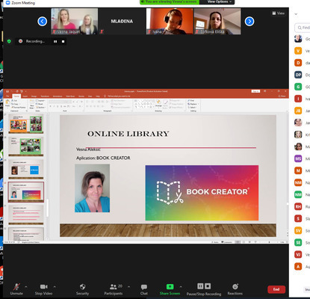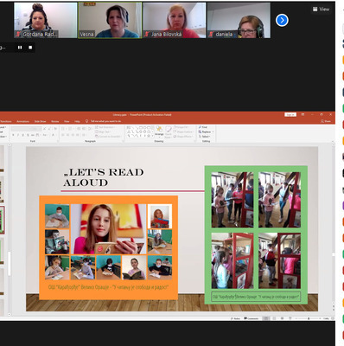
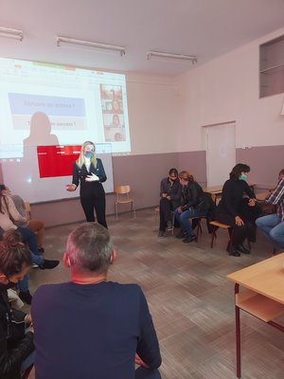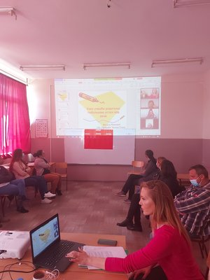
On the final day, colleagues Mladjena Momcilovic and Aleksandra Aleksic held a presentation on the "Inverted Classroom", after which ideas were exchanged on how to create it. The final word was given by Vesna Aleksić as well as the school director, after which an evaluation of the activities was done. After the activities, the coordinators of both teams, Gordana R and Danijela T, had a final meeting to evaluate the success of the work done and to agree on the further course of the project. The next LTT activities are planned for mid-May, when the hosts will be partners from Slovakia.
VIDEO LINK > https://youtu.be/5GveYhRPOyM
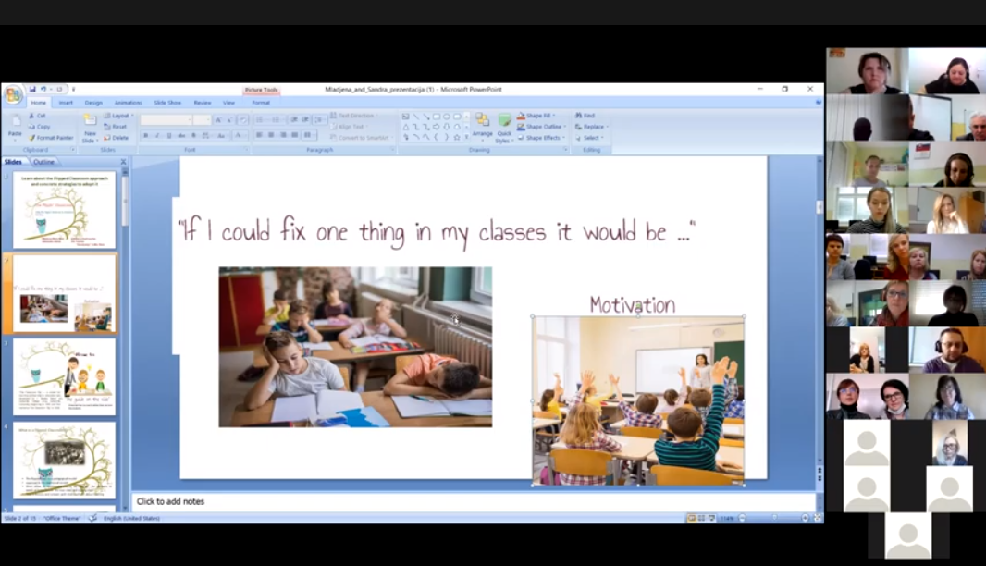

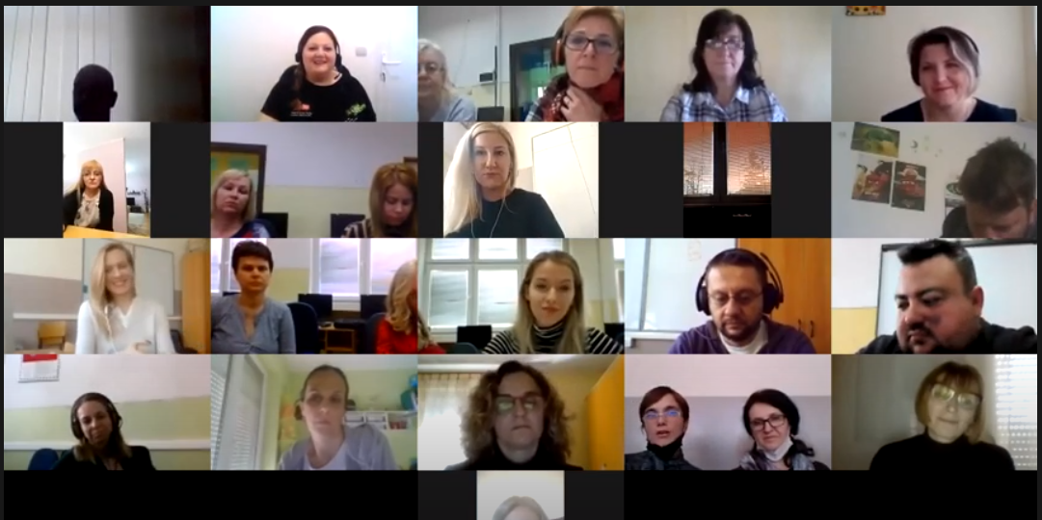
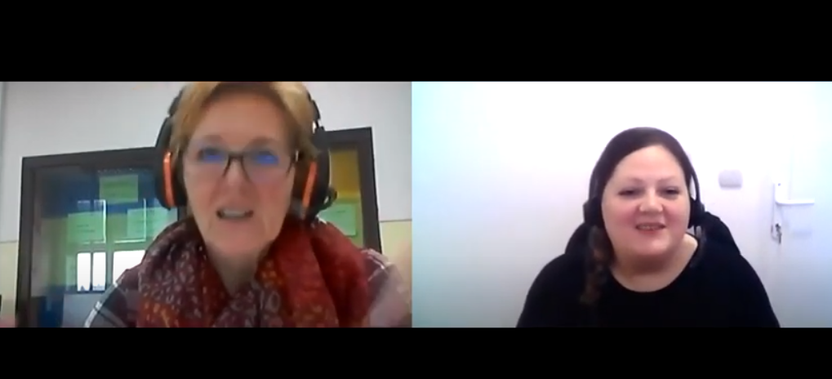
All the videos, presentations and other materials are on out Twin space for all of our teachers to use.
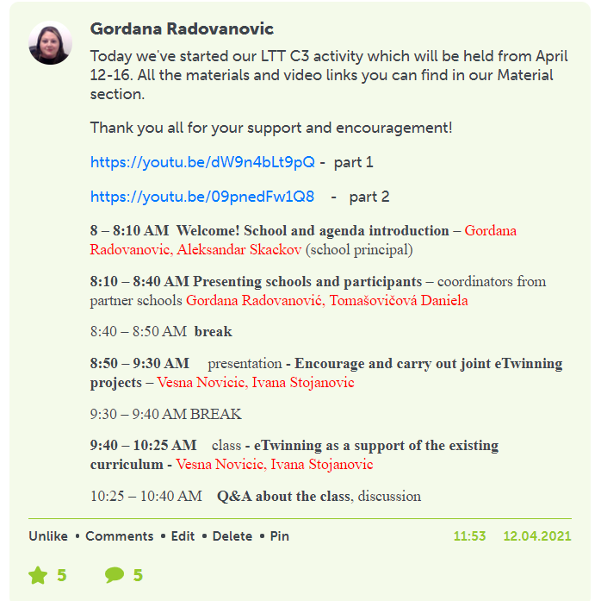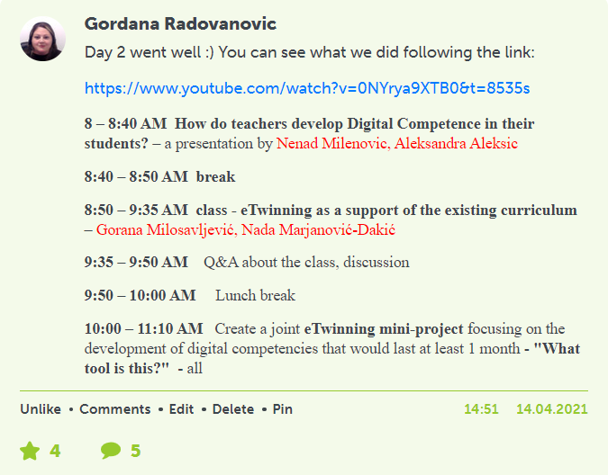
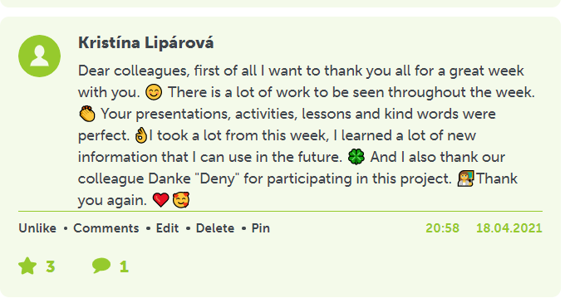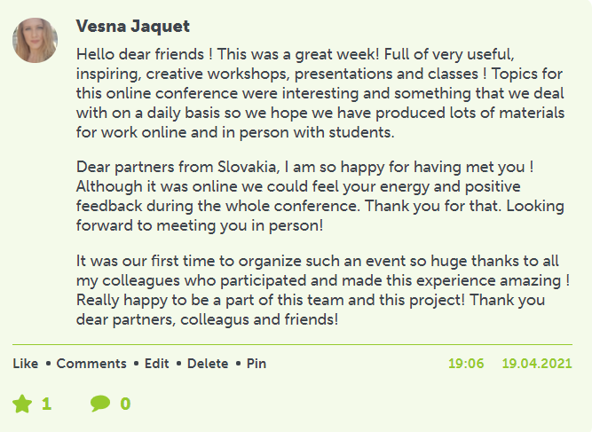
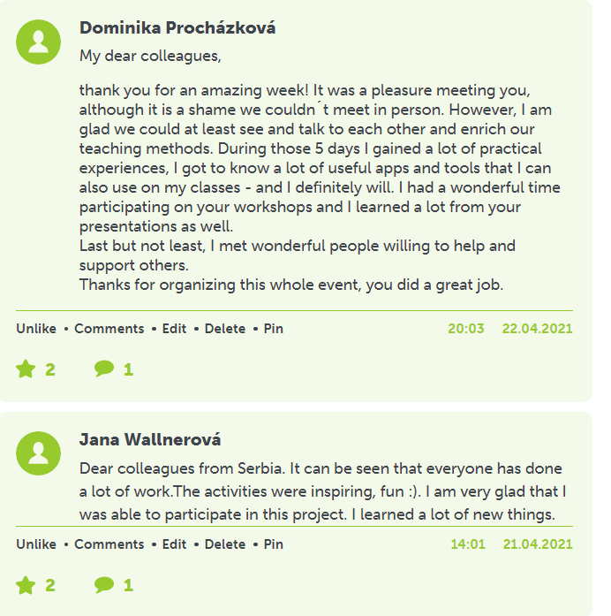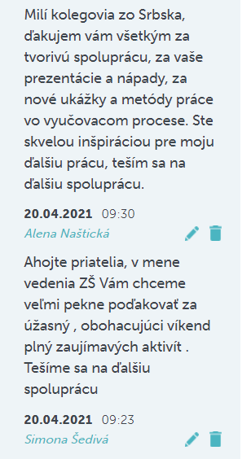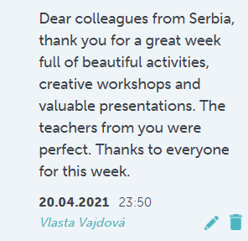
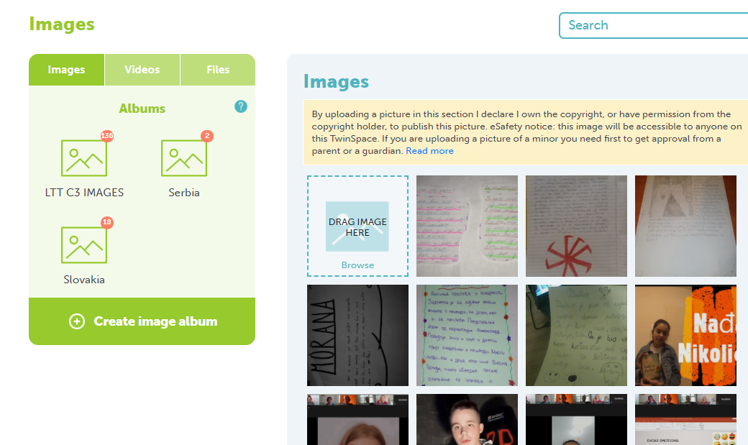
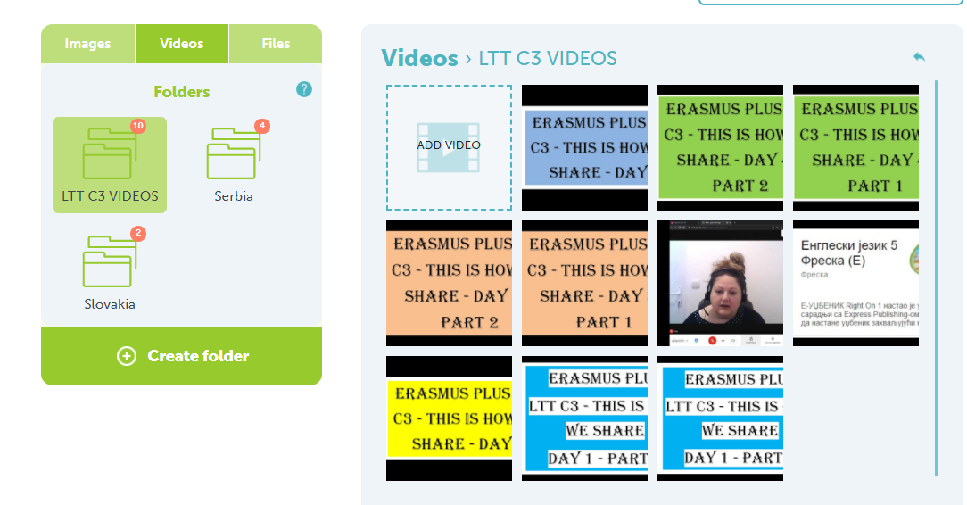
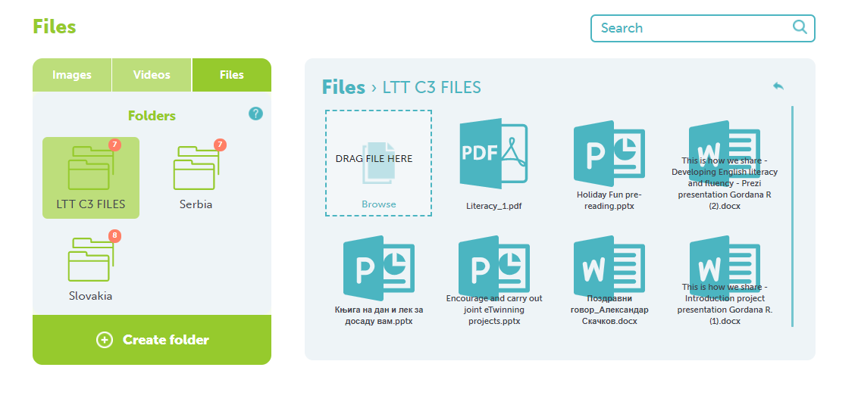
Dissemination of the project – school site, school magazine, project site, eTwinning, local TV

https://youtu.be/6s8MHj05OnY
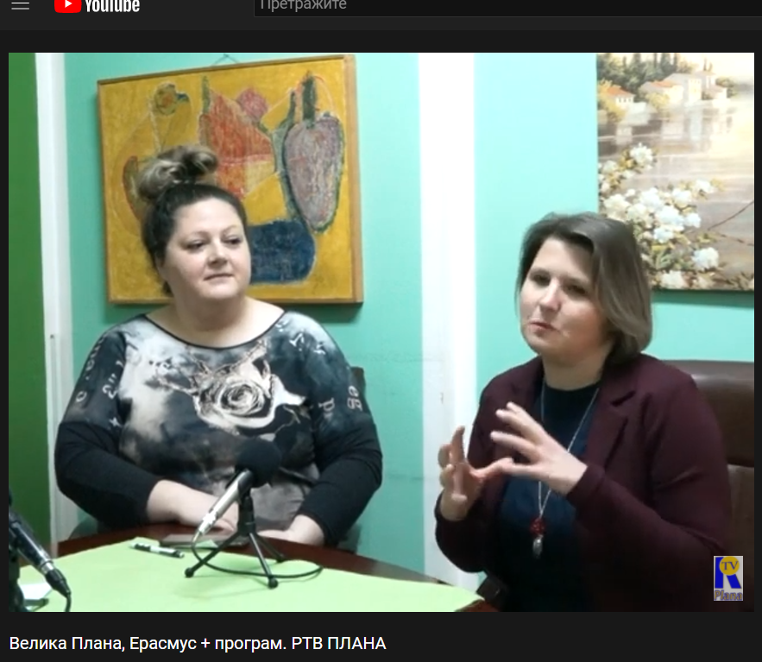

May 2021
In the days of 10th to 13th May 2021 the second teachers´ training took part. Due to pandemic situation which didn’t allow us to travel, we had to realize all the activities online using ZOOM conferences like during the previous one organized by coordinating school from Serbia, in April. The host was Slovak school. 12 teachers, 8 parents and 4 representatives of local community took part. Participating school was Elementary School Karadjordje, Velika Plana, Serbia. There, 12 teachers took part as well. The programme consisted just of working activities like presentations, workshops, lectures, lessons, meeting with parents, questionnaires and discussions, social and cultural events were excluded because of already mentioned situation.
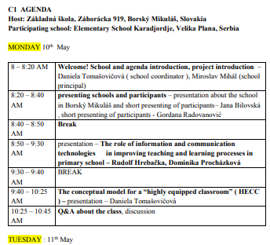
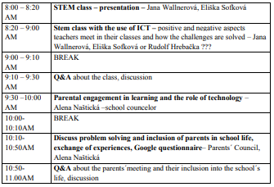
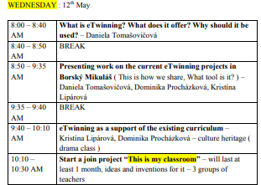
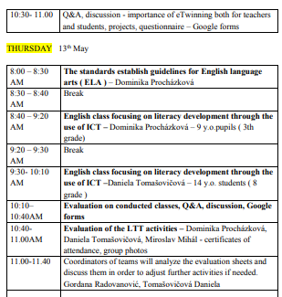
There were 36 participants involved: 12 from Serbia, 12 teachers from Slovakia, 8 parents from Slovakia, 4 representatives of the local community and representatives of the local media.
Monday : https://youtu.be/rWsrBVg8pgA
- Introduction, Greetings from Borsky Mikulas headmaster Miroslav Mihál and the project coordinator Daniela Tomašovičová
- Introduction of the project – The way of our project – from the start in Tromso (contact seminar) till now, aims and objectives, already realized activities and outcomes – Daniela Tomašovičová
- Presentation about Slovakian school – history, building, rooms, activities – Jana Bilovská
- Presentation by Rudolf Hrebačka and Dominika Procházková about Information and communication technologies in learning processes. They presented the most common ICT equipment used in our school and in general, and why it is necessary to implement ICT to the teaching process. They introduced the best-known educational portals that our teachers use and also the best known education portals for English teachers. Their advantages and disadvantages were mentioned as well. The aim was to depict the role of ICT and to conclude that ICT is becoming an essential part of the teacher's work
- Daniela Tomašovičová presented a model of HECC – highly equipped and connected classroom, the bases from which it is coming out – Digital Education Plan and the 2nd survey of schools: ICT in education. She introduced 4 dimensions as a base of this model, 3 scenarios to describe different levels of HECC, estimated costs to get it and possibilities of connection an average EU classroom with advanced components of this model. She also mentioned possibilities of funding (Erasmus plus and European Social Funds) and tools for exchanging best practices ( eTwinning and School Education Gateway) At last, 9 itools were presented as the best way how to connect classrooms all over the world.
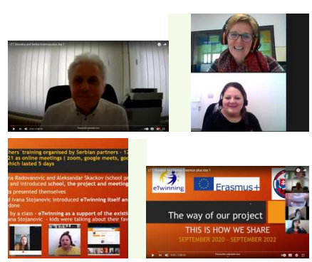
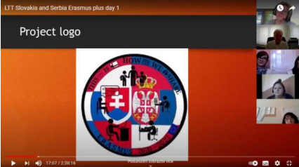
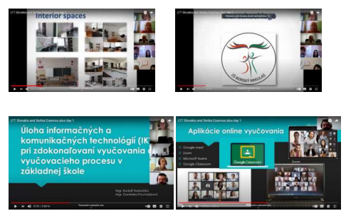
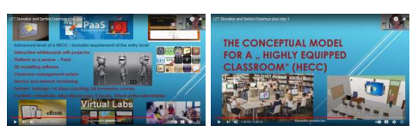
Tuesday : https://youtu.be/3NR4dkRgXwA - part 1
https://youtu.be/E578IcWCU4k - part 2
https://youtu.be/0sZdkg-DXtM - part 3
- Serbian partners introduced themselves one by one
- Presentation about STEM class by Jana Wallnerová and Eliška Sofková. Slovakian Physics/Chemistry and Math teachers presented on STEM education. They explained what STEM stands for, main objectives, pillars, what the required skills for STEM teacher and benefits for students when being active in STEM education are. They also played some interesting videos to support their claims. Their aim to explain STEM in details, raise awareness and curiosity in STEM education was fulfilled. They also showed how STEM is applied into the education process in our school.
- After that Rudolf Hrebačka had a STEM class with the use of ICT with 6th and 8th graders. Students were working in two different digital platforms, according to their skill levels. Younger students used program Scratch and older ones used Imagine. Some students were also programming robots. They had to use the programming language and program robot to move according to their instructions.
- Then Alena Naštická – school councelor - had a presentation on Parental engagement in learning and the role of technology. They were dealing with the current hot topic – dual education. Firstly, she talked about the ways how our school involves parents into its life, how we collaborate and cooperate together. Then she presented what dual educations is, what the advantages, benefits and possibilities for students are. After that she had a meeting with parents of 8 graders about dual education. Her aim was to inform parents about this possibility of further education, its advantages, benefits for students, she was talking about admission procedure, high school applications, she showed them a temple of application and gives some useful advice how to fill it in. In the end, she informed the parents about dual education and gave a lot of practical information.
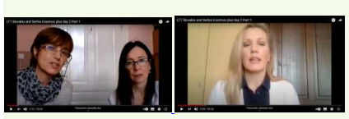
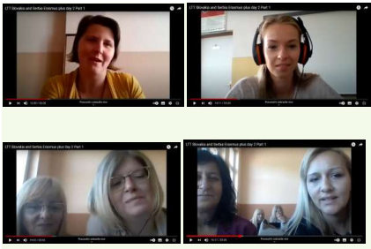
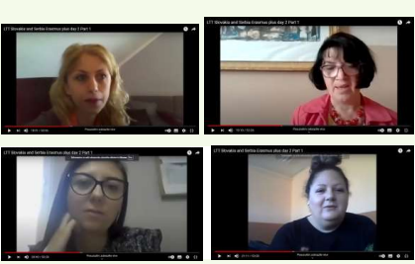
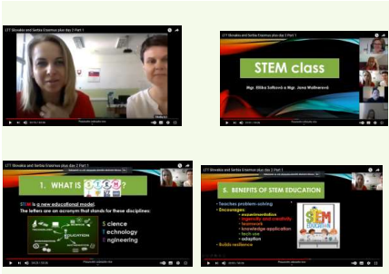
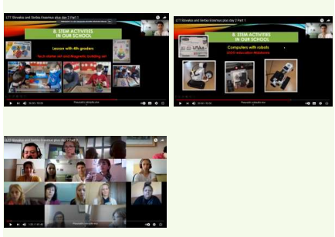
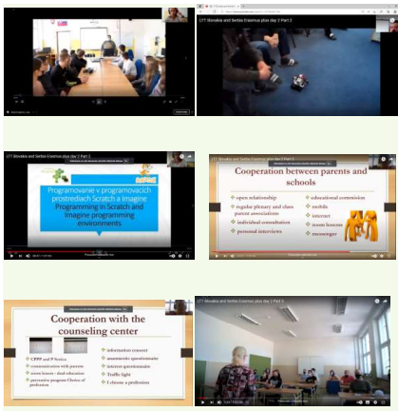
Wednesday : https://youtu.be/VUOmpz3J8dE - part 1
https://youtu.be/B6d1RZfmQ58 - part 2
https://youtu.be/espplgZplds - part 3
- In the morning, Daniela Tomašovičová had a presentation on eTwinning – her aim in this part was to explain what the platform itself is, what it offers, what we can find there and why it should be used. She showed some very useful links, videos and materials, introduced the projects which were done by our school in the past, she gave a lot of practical information about working in the twinspace and what can be found here on eTwinning – materials for teachers, various groups, manuals, seminars, webinars, partners for the projects, project kits etc.
- After that Daniela Tomašovičová and Dominika Procházková talked about the two ongoing projects – the main project: This is how we share and a sub-project: What tool is it. We described in detail what are the projects about, what materials have been uploaded, members of the projects and their progress. They showed both twinspaces with all the materials, pages, members, communication.
- Last but not least, we started a new joint: This is my classroom – both sides discussed ideas that could be covered within this topic and future teams as well as we chose the creators and implementers of the project.
- The last activity was an „online“ lesson on Cultural heritage in Slovakia. It was an interactive lesson with students from 5-7th grade portraying our customs and traditions, including singing a folk song. Kids were wearing typical folk costumes of our region. This class can be found on YouTube https://www.youtube.com/watch?v=kY3RON-LyI8&t=140s
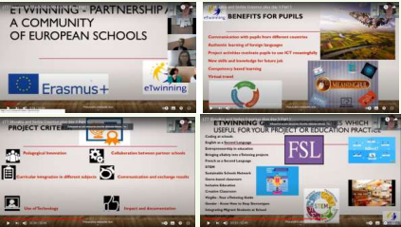
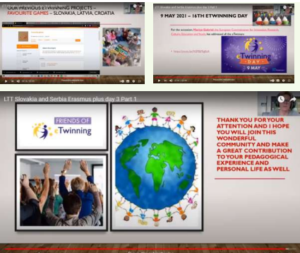
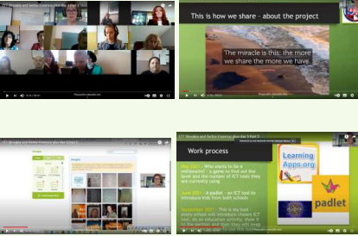
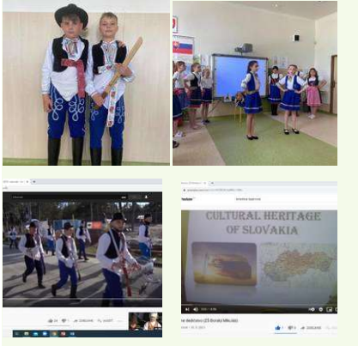

Thursday : https://youtu.be/0lgrjcUAIQc - 1st part
https://youtu.be/vRvrNVwnFcE - 2nd part
https://youtu.be/z7CRW2VrNKk - 3rd part
https://youtu.be/VIY2kZ4p7rM - 4th part
- On the last day Dominika Procházková had a presentation on English Language Arts (ELA). She was mostly concerned with the use of English as a Second Language (ESL) and the use of English as a Foreign Language (EFL). She explained differences and presented the needs for such students. At last, she described the CEFR language skills and offered a few tips to English-teaching.
- The presentation was followed up by two online English classes – first with 9 y.o. pupils (3rd grade) and the second with 14 y.o. (8th grade). In both lessons ICT was used – interactive board and tablets. The first class was led by Dominika Procházková and she used Family and Friend online practice to confirm the topic about description of people. In the last part of the lesson, she did Kahoot quiz to get a nice feedback from her kids. The next lesson was managed by Daniela Tomašovičová. The topic was Australia and the teacher used CLIL method. She also used interactive board and tablets. After watching a video about Australia they worked with a book – a text about this country, they were talking about the information they got from both sources. They listened the text using online practice to Project fourth edition. To get a feedback she played a Kahoot quiz as well.
- Then evaluation of all the meeting was realized by all the participants, and Dominika summarized all the activities to remind what was presented. After that all the participants filled in the questionnaire to evaluate the meeting. In conclusion, both coordinators had a meeting to evaluate LTT and talk about next activities and practice, dissemination and financial issues.
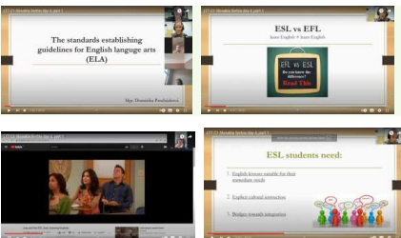
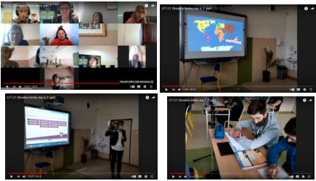
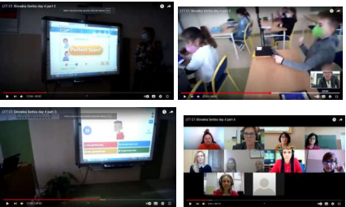
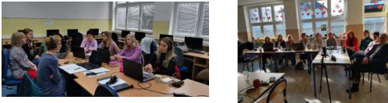
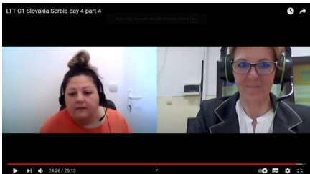
Looking at the programme and the results of the questionnaire it is obvious that we prepared various and educative programme consisted of suitably chosen combination of presentations on topics related to the aims of the project, workshops, discussions, lessons, enquiries or lectures. We also showed to our partners how our school cooperate with parent community. We hope that our partner school was satisfied with the activities, they will be able to enrich their education process and they will be able to use the knowledge in the further practice. And this is one of the main aims of the project – enrich each other, learn from each other, share experiences, make education processes more modern and effective, adjust it according to the demands of the new age and make it more interesting and attractive for both students and teachers.
Etwinning mini project 'What tool is it?' is focused on using various ICT tools in learning and teaching processes in both partner schools Serbian and Slovak following the aims stated in Erasmus+ project 'This is how we share'. Younger students took part in a few quizzes related to ICT online tools and apps. They learned what each tool is for and how they can use them for learning. The main focus was on digital competencies. Five teachers took part in this project. Natasa Mihailovic and Vesna Jaquet from Serbia and Daniela Tomasovicova,Dominika Procharkova and Kristina Liparova from Slovakia. Students enjoyed the project. 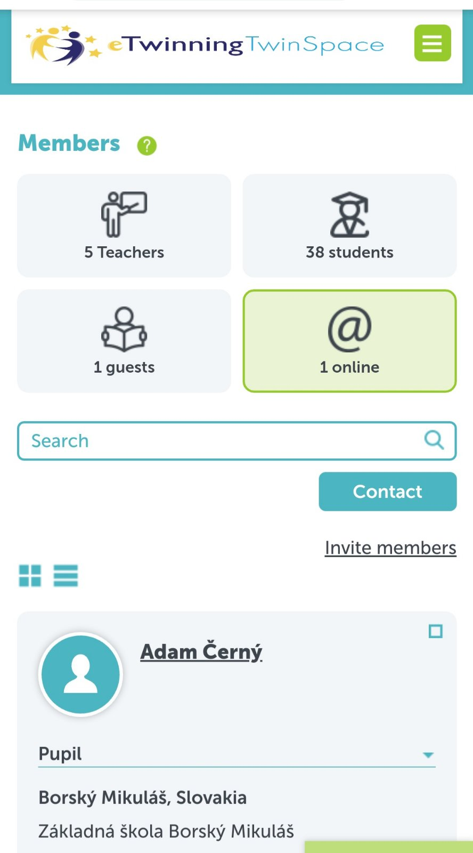 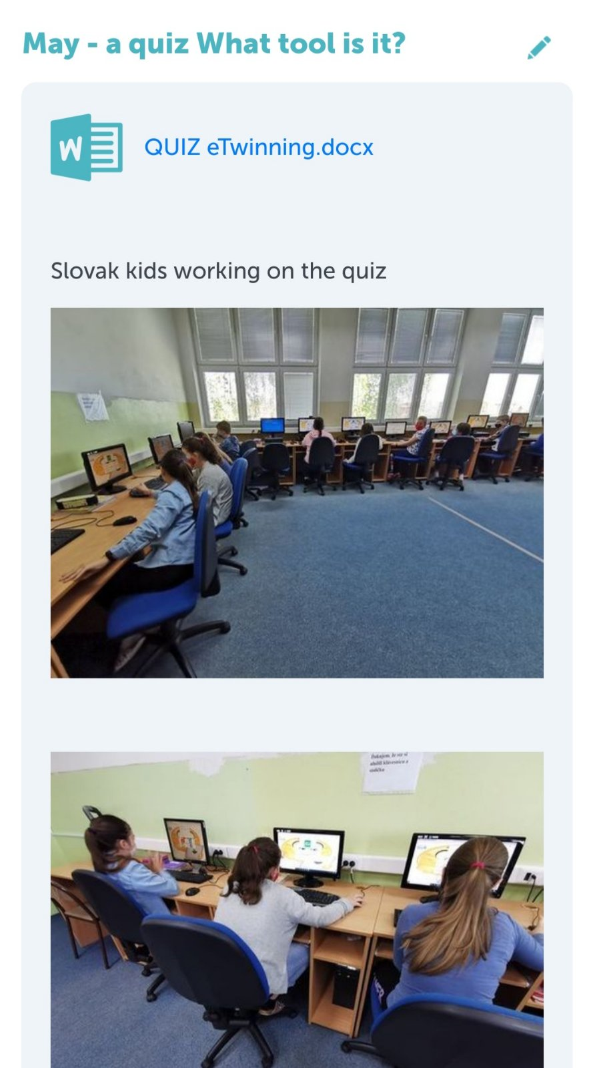
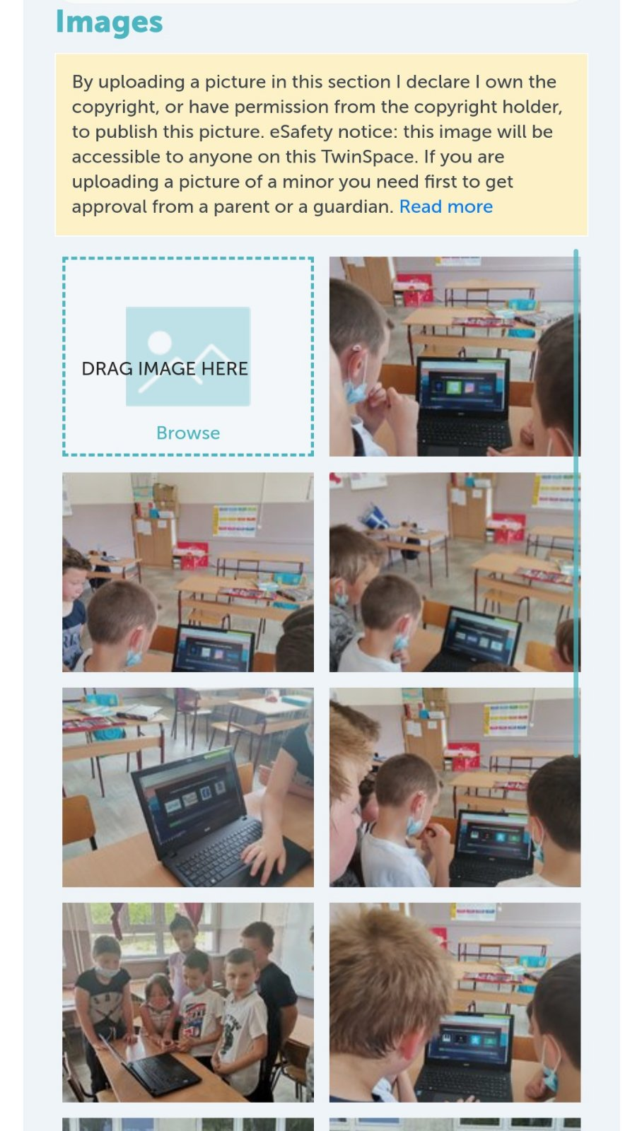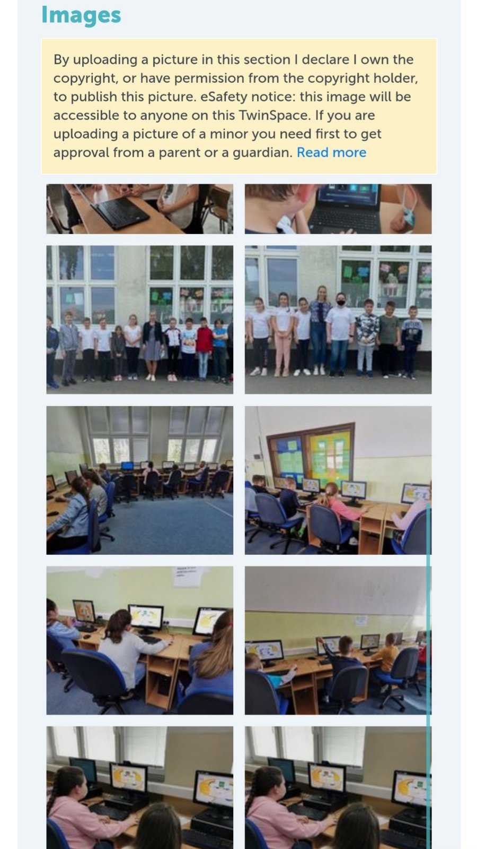

June 2021
ETwinning mini project – My classroom – This activity is the practice activity of our main project This is how we share. During the May LTT activities teachers were being trained to actively use eTwinning in their classrooms. The task was to practice English and develop creativity by picturing your dream or real classroom. Teacher Gordana, and English teacher from Serbia did this activity with her 8-graders and Jana Wallnerová and Eliška Sofková. Slovakian Physics/Chemistry and Math teachers did this activity with their 9-graders.
Students enjoyed the process and had great fun making posters. Everything is on eTwinning space.
Guest A - guest.a.1.2.3.4.5
